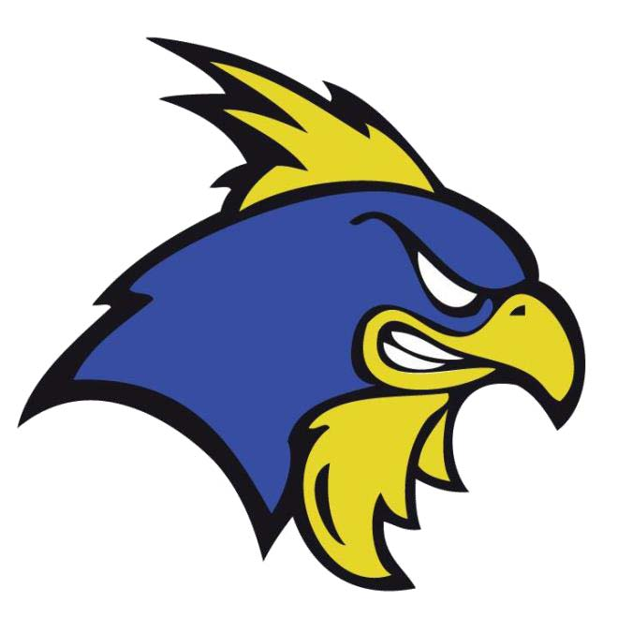

Jr. Blue Hens

2019-20 Season
Sponsorship Opportunities

Who are the Jr. Blue Hens?
•The Jr. Blue Hens (JBH) are a non-profit, USA Hockey,
Tier II youth hockey club that play out of the University of Delaware Ice Arenas located in Newark, DE
•For the 2019-20 season, we will field nine teams ranging from Mites (U8) to Midget Major (U18)
•We are members of the Delaware Valley Hockey League (DVHL) and the Atlantic Amateur Hockey Association (AAHA)
•We believe our purpose is to:
–Educate, promote, and encourage the sport of ice hockey
–Teach players the fundamentals of ice hockey
–Provide players with the highest level of compatible competition consistent with the financial resources of the corporation and its members
–Instill in our members and players a sound appreciation of fair play and healthy competition
–Promote sociability and friendship among our members and players
•For more information about JBH, visit our website at www.jrbluehens.org or follow us on Facebook at www.facebook.com/jrbluehens
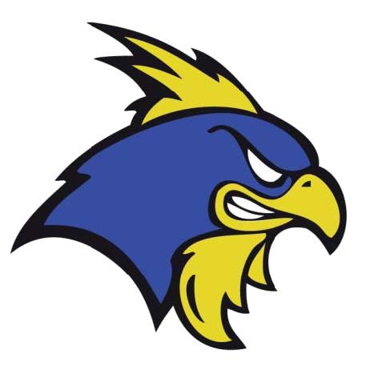
JBH Blue Line Package $500 Donation
•Logo on JBH website until 3/31/2020
•Logo in annual End-of-Season Banquet program
•Three sponsored posts on JBH Facebook page
•Two “News from Our Sponsors” mentions in Chicken Wire e-Newsletter
•Plaque presented to sponsor recognizing support of JBH
Power Play Package
$1,000 Donation

•Logo on JBH website until 3/31/2020
•Logo in annual End-of-Season Banquet program
•Four sponsored posts on JBH Facebook page
•Three “News from Our Sponsors” mentions in Chicken Wire e-Newsletter
•Plaque presented to sponsor recognizing support of JBH
•Recognition during JBH-sponsored events (e.g. Stick & Pucks, Holiday Party, etc.)

Hat Trick Package $1,500 Donation
•Logo on JBH website until 3/31/2020
•Logo in annual End-of-Season Banquet program
•Six sponsored posts on JBH Facebook page
•Four “News from Our Sponsors” mentions in Chicken Wire e-Newsletter
•Plaque presented to sponsor recognizing support of JBH
•Recognition during JBH-sponsored events (e.g. Stick & Pucks, Holiday Party, etc.)
YES! I want to be a sponsor of the Jr. Blue Hens!

Company/ Organization: __________________________________________________________
Contact name: __________________________________________________________
Email address: ____________________________________
Phone #: __________________________
Participation level:
◻Blue Line ($500) ◻Power Play ($1,000) ◻Hat Trick ($1,500)

**Please submit participation form and high-resolution logo to pr_web@jrbluehens.org by 9/15/2019 to ensure complete execution of deliverables throughout the season.
Please mail checks made payable to the Jr. Blue Hens to:
Delaware Jr. Blue Hens
PO Box 7825
Newark, DE 19714

Thank you for your support of JBH! Remember, we are a non-profit organization and your donation is tax deductible.

