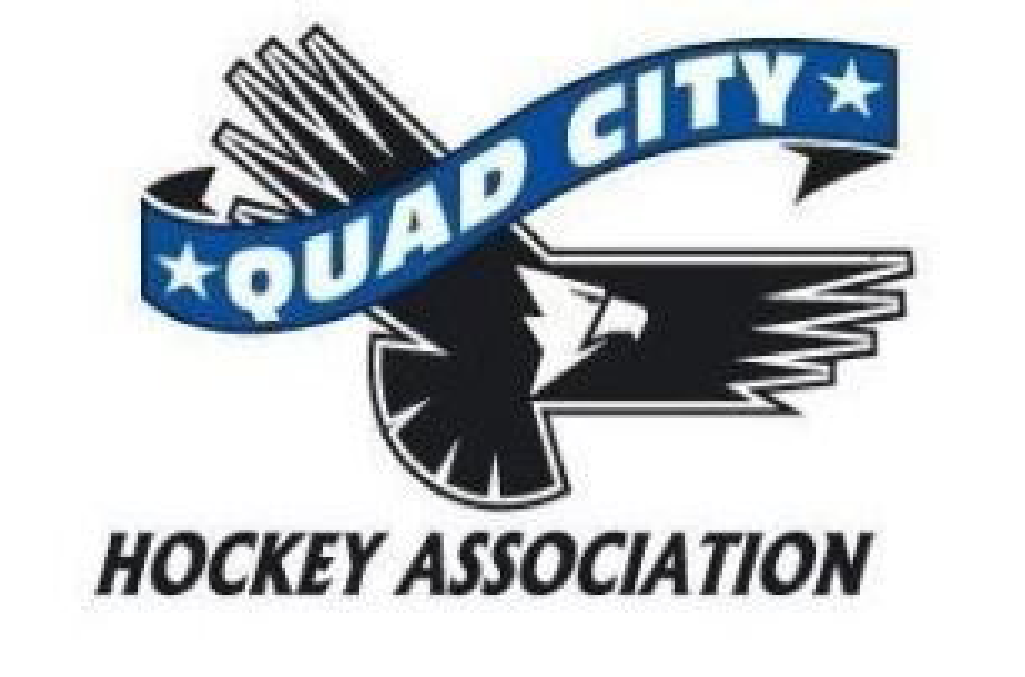
Minutes
Monday, November 6, 2023
6:00 pm River’s Edge Conference Room

10 min | Call to Order: 1800  Approved Absences – Andrew Quinn, Kerry Toporowski, Todd Ashby
45 min | Director Reports  President – Rich Oswald  - New rink has hit some setbacks secondary to a loss of glycol for freezing as well as some losing of pressure.  - The rink is still going to have ice but the start date is set back and TBD.  - Ice schedule is changing constantly at this time secondary to the second rink not being present  - Heather Tysma is the primary ice scheduler  - Any and all roster changes have to go through the registrar before those players hit the ice  Vice President – Andrew Quinn – not present  Past President- Melody Wright  - Safe Sport Update – Hate Language – 3 game suspension for any hate language on the ice. This includes “the N word”, “the F word” and now “the P word” any these can all come with a minimum 3 game suspension mandatory. Any comment that is based in gender or nationality or religion will be included in hate speech. This PARTICULARY is problematic ON ICE and heard by an official. It can be a USA hockey violation for any hockey related times on or off ice.  Treasurer – Megan Hoffman  - Budget proposal – Looking to make a budget committee to go though the budget carefully to be sure that this is accurate. (Melody Zach, Megan and Michelle plus other volunteers)  - Good feedback with invoices to teams and the refs are very happy that they are getting paid in a timely manner by one person.  - Venmo messages to Megan has to have what specifically it is for in the tag line  - Finance by-laws – There need to be some updates to these which falls under the duties of the Vice President  - There is some lag with getting ice bills from the River’s Edge and Megan is looking to streamline this as soon as possible.  Secretary – Rich Blunk  - River’s Edge QCHA Internet Update – Mediacom up and running well. If we want to make a change we have to notify of end service 30 days before it will stop.  - The city will pay for Metronet installation into the rink if we sign over LiveBarn to the city.  Coaching – Zach Honert  - Coaches’ gifts – There have been some complaints about no coaches’ gifts in the past. Typically, this does happen, but the amount has varied. This is important because we want to retain coaches.  - Getting a cloud based storage to have documents stored for consistency of knowledge and programming could be very useful. Zach is planning on looking into this for the next board meeting.  High School – John Gray  - Good season kick off at home and the first away weekend was very successful.  - Lights are needed in the back hallway and John is going to talk to the facility about this.  - Injury credit will need some increased transparency and clarity to the parents.  Travel – Kerry Toporowski – Not present  House – Phil Harms  - HL is going well thus far. The schedule has been jumbled secondary to the second rink not being done yet.  - Games kicked off this weekend for HL and select teams are starting to travel already.  - Thanks to the QCHA kids working with THFF as volunteers.  DHSD – Dillon Fournier  - October was frustrating secondary to ice constraints but has been able to get out with some house league and mini mites  One Goal – Allen Arndt  - Great turn out for THFF (over 90 kids) as well as for One Goal (over 30 kids) out today starting the program. This One Goal session is once per week.  - Wanting to do a THFF during the holidays before the next One Goal session.  At Large – Volunteerism –Heather Tysma  - Pictures are on hold until December secondary to ice scheduling having teams here and at Vibrant  - Scheduling for ice – the coaches and managers have been very flexible and understanding. Working on getting a more consistent schedule asap for with and without the second rink  At Large – Asset Management –Libby Montenguise  - 2 good sales for socks and jerseys but there are still more people needing this and it has been difficult at times  - There are still select teams looking to order travel type jerseys but it is an 8 week lag and so if they do order them they will not be in before Christmas.  - Getting travel jerseys is much more difficult for a whole team of young kids as opposed to just a couple on the U 18 team.  - The vending machine issue is on hold until a budget is done  - Will potentially need to address the uniform policy as it specifically states that the select teams are to wear the house league jerseys.  At Large – Community Engagement and Storm Update– Kate Oswald and Storm Staff  - Kate has nothing  - John notes that the THFF was great and he is hoping to support one if there is one in December  At Large- Girls Team- Todd Ashby – Not present  Registrar Update - Michelle Arndt  - Try Hockey For Free 91 players, 90 of these are brand new to hockey, 123 signed up  - 29 of the One Goal players of the 38 came from the THFF event  - $1,200 raised for breast cancer research by the girl’s team
15 minutes | New Business: Closed executive session for the first  Mike Hurd present as the Midwest team representative. Talks about the post season team that went to St. Louis for exposure to scouts. This year looking to take a full team of girls for this event as well.  Try outs for this will be posted soon they will be at Ames and the week after the MWHSHL tournament  Preseason team went up to Blue Ox and played there as well as in Chicago and to Shattuck St. Mary’s and a Silver Stick event in Denver. This team is comprised of HS players from around the MWHSHL Always looking for coaches and managers to help with this  Due to inconsistencies with the Storm 50/50 and 501c3 status of the Quad City Storm One Goal Foundation the QCHA is suspending these activities until gambling license is confirmed and verification of status is done.
 | Adjournment: Motion by Rich Oswald second by Libby Montenguise and passed unanimously 1924

Next Meeting: Monday, December 4, 2023, 6:00 p.m. River’s Edge Conference Room

