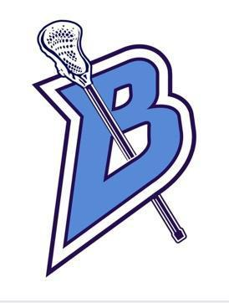
Meeting Agenda
March 20, 2024

Attendees: Amy Davidson (President), Nicole Neis (Vice-President), Amy Pierpont (Secretary), Chris Letourneau (Equipment), Others: Alex Johnson, Michelle Aber, Danielle Flannigan, Julie Letourneau, Sammy Esteves

- CALL TO ORDER:

    - Date: March 20, 2024 Time: 7:08p.m.

- PRESIDENTS REPORT:
  - Vote to pay Ethan for Adrenaline- Approved for $350
  - Volunteers needed for uniform handout-2 volunteers (Julie, Danielle)
  - Cheerleaders confirmed for games 5/13 and 5/22 Youth and Senior nights
  - $1000 to spend for Senior night
  - Other 2 committees stay at $500

- SECRETARIES REPORT:
  - (Review last meetings minutes)
  - Approved--- Nicole, Chris 2nd

- TREASURERS REPORT:
  - (Financials)
  - Balance--$34,551 that includes beer bust, earned $4500
  - $298 from Chipotle fundraiser

- NEW BUSINESS:

- Gear handout 4/4 6p-8p. Amy has checklist and will assign a station.
- Egg Delivery 3/30- 16 families signed up. March 22nd deadline.
  - Alex to send out form to players to see who can participate, drive, etc.
- Chipotle Fundraiser (March 19 5-9)
- Pancake Breakfast (March 23)
  - We have enough player volunteers from group chat
  - Include in email that parents can bring donation items to the pancake breakfast
- Vertical Raise April 3 start date (hold meeting)
  - Email fundraiser
  - Players put in 10 emails each
- Team Bonding Event 03/24
- Team photos 4/19 players arrived and dressed at 3:15
  - Outside
  - White unforms
- Youth Night, Parent Night, Senior Night
  - All dates and dibs are up for these events
  - Dibs are semi-filled, need more volunteers
- Concession Stand Donations - sign Up Genius
- Sponsorships - Blaine Festival, Chick Fil A, CoBank, Bell Bank
- Chris volunteered to work the scoreboard
- Treasurer assigned (Sammy Esteves)

- OLD BUSINESS: (recap)
  - Parent meeting (Feb 26)
  - Off Season Training (Mar. 18-23)
  - New Volunteer spots (Volunteer Coordinator, Special events coordinator, Easter egg Chair) Don’t have one
  - Beer Bust (Mar 2)

- COACHES CORNER
  - Cleaned out lockers
  - Alex will get locks for the lockers
  - Nicole offered to get shampoo, conditioner, soap for locker room
  - Host a cross fit class at local gym in Roseville. Alex will coordinate.
  - No practice next week
  - B squad schedule will be out by the end of this week

- ADJOURNED:

Date: March 20, 2024 Time: 8:00p.m.

