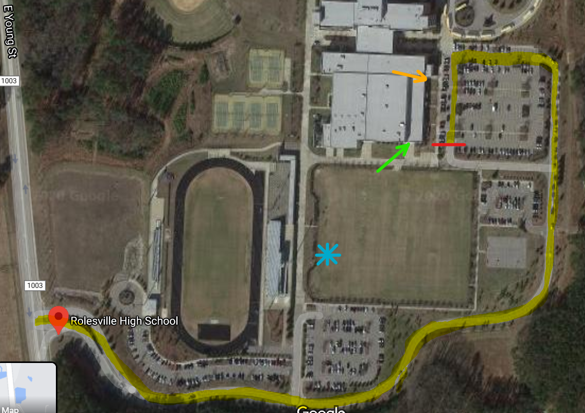

All Indoor Athletes must exit the building through the doors by the Laundry Room ONLY (Immediately after conclusion of workout).

Health Screening location (athletes remain in vehicle)

Athlete Parking

All Athletes enter campus from the E. Young Street Entrance and drive around to the usual carpool drop-off location (Highlighted in yellow).

Outdoor Athletes report immediately to their assigned location.

Indoor Athletes may ONLY enter the school through the doors by Mr. Stiles Room (across from Practice field).