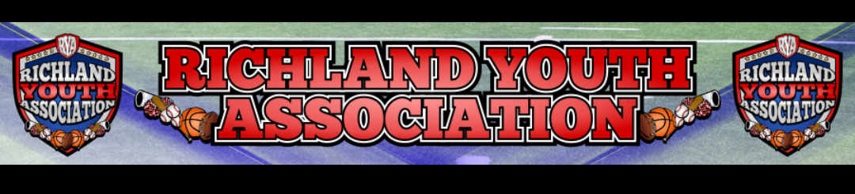
RYA OCTOBER BOARD MEETING
Meeting Date: October 5, 2022 – 6:30pm
Attendees: Mike Cowan, Ben Earley, Blair Armfield, Richard Stutheit, Lisa Willis, Eric Gomez
Absent: Kevin Vorpahl and Marissa Jennings

General Board Items / Old News
- Damaged scoreboards – Baseball Field #3 (not working) and Football Field (knocked over)
- Restitution Payments – no payments made recently

Rec Baseball: Richard Stutheit
- 13/14u parents will all receive a partial refund (TBD) for this season due to reduced practices and games since Justin 14u backed out and field is damaged
- Pirates 12u coach withdrew from team – team being coached currently by two of the assistant coaches
- Field Conditions:
  - Richfield Park #2 – damaged backstop should be fixed by middle of next week
  - Cross Timbers #1 – home plate is damaged
  - Richfield Park Fields – sprinklers were left on Friday night and multiple fields needed extended work to get fields playable.
- Baseball Uniforms:
  - Zexez jerseys were all perfect
  - Hats had a few issues, but getting new hats produced for 6u Rangers and awaiting a few missing items

Football: Eric Gomez
- Grandparent banned from future RYA football events due to behavior
- Coach Malcolm Brown passed away – balloon release at next home football game
- Teams are all 4-1 except for 9u which is 2-3 on season
- End-of-season party – renting a tent and heaters to host party
  - Will need a city permit for the event
  - Possible date of December 10th
  - Possibly using The Link (RH) for indoor gathering if smaller event (12u team only)

Cheer: Lisa Willis
- Upcoming Dates:
  - Pictures on 9th / 16th
  - October 21st – RYA Night for RHS vs BHS (FAAC)
  - October 28th – RYA Carnival on Friday night on Football Field
- Uniforms –
  - Cheer Zone uniforms were outsourced to China
  - $25/uniform to get uniforms altered through Tierra Alterations
  - Cheer Zone agreed to have $13 reimbursed for each uniform top, potentially $780 total refunded for alterations – money would go to the parents.

Basketball: Blair Armfield
- Currently have 37 active registrations for basketball
- Pre-Season Schedule:
  - Coaches meeting changed to 10/26 from 7-8pm
  - November uniform fittings on 11/6 from 3-5pm
  - Coaches Draft on 11/12, time TBD
- Need increase in volunteers for basketball games – looking at high school students for volunteers
- 8 game seasons for all basketball teams
- Possibly hosting a post-season event at Richfield Park with bounce houses

Marketing: Marissa Jennings (absent)
- Possible sponsorship opportunity at Smithfield Elementary School Fun Run

Premier Baseball: Kevin Vorpahl (absent)
- October tournament did not have enough teams for this weekend’s tournament

Meeting adjourned at 8:40 pm

