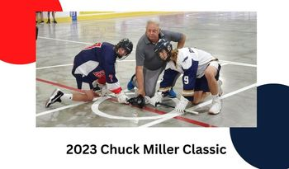

A/B Tournament
JUNE 16-18 2023
Fee: $925.00
Payments accepted through Peloton, or e-transfer to regalsboxpayment@gmail.com - use password: chuckmiller
Mail Payments to: Guelph Minor Lacrosse c/o Tricia Chilton
156 Silurian Drive, Guelph, Ont. N1E 7E7
4 games Guaranteed
No refunds after May 15th 2023.

1.) Team Name: ______________________________.
2) Division (U9, U11, U13, U15, U17): __________. 3) 2023 Ranking _________________.
4) Home Jersey Colour ______________. 5) Away Jersey Colour ______________.
6) Coach Email address _____________________. 7) Coach Phone #: ___________________.
8) Manager Email address ___________________. 9) Manager Phone #: _________________.

Tournament Chair - Tricia Chilton
Email: t_chilton@rogers.com
Phone#: 519-362-2654

