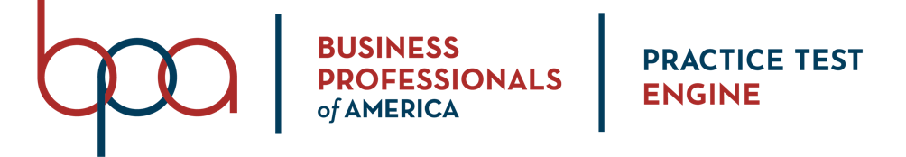
ADVISOR GUIDE

Student Member Registration Instructions

Follow the steps below to purchase access to the BPA Practice Test Engine for your student members.

- Navigate to the BPA Membership Registration System (https://register.bpa.org) and log in.
- Click on the “BPA Practice Test Engine” tab (highlighted below).
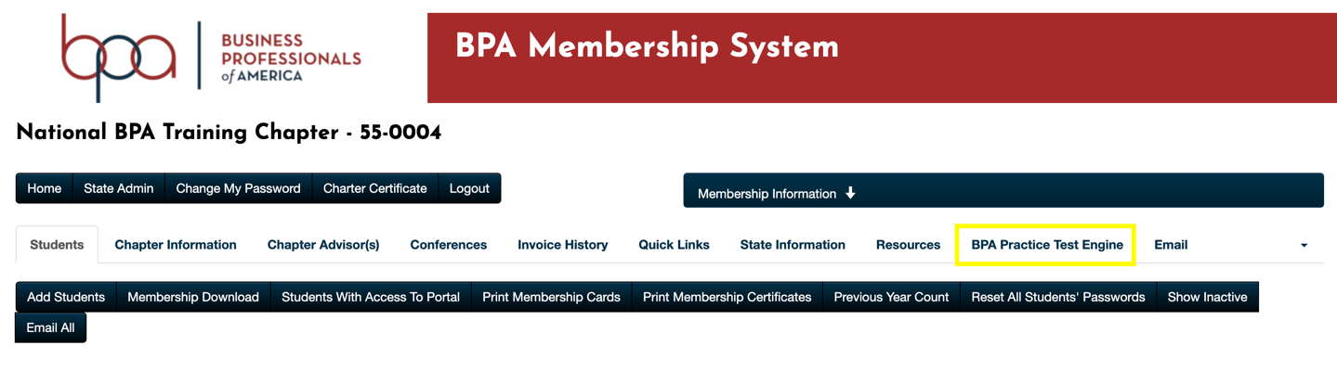

- Select the members that you would like to purchase access for.
  - NOTE: Members must be submitted under the Students tab for them to show in student list.
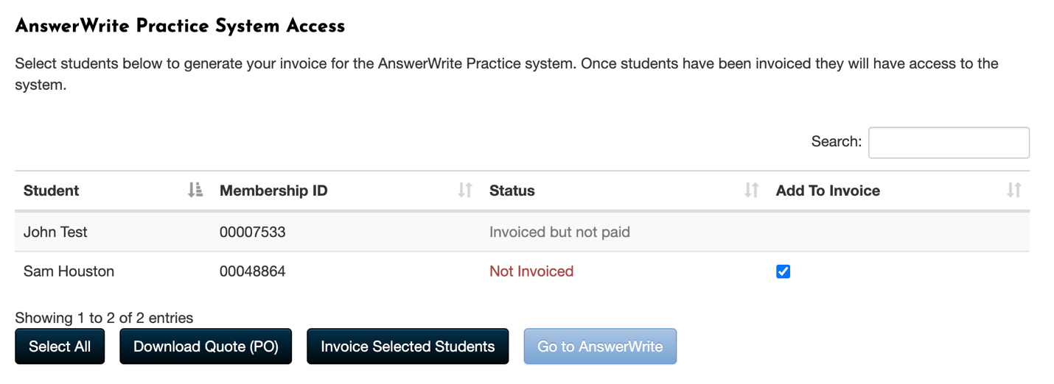

- If you need to generate a quote before an invoice can be generated, please click on the Download Quote (PO) button.
  - NOTE: Members added to a quote will not receive access to the system until they are officially submitted on an invoice using the Invoice Selected Students button.
- To obtain immediate access for your students, click on the Invoice Selected Students button to generate the BPA Practice Test Engine purchase.
  - NOTE: Invoices may be paid immediately via credit card or submitted for a check payment.
  - NOTE: Access is immediately granted for all members who have been invoiced and the local chapter is responsible for all invoices when they are generated.

BPA Practice Test Engine Report Viewing Instructions
Under the BPA Practice Test Engine tab, there are two different reports (see below for details and a screenshot) that will aide Advisors in tracking the tests that their members have taken.
- Test Attempts Report – This report will show all test attempts that have been attempted by members within the chapter categorized by test and year.
- Utilization Report – This report will provide a list of members (who have been invoiced) and whether or not they have accessed the BPA Practice Test Engine system.

