Dru Hammond, PNAHA President, called the meeting to order at 9:00 am.
Note: Committee Round tables occurred prior to this meeting. Registrar meeting held September 13, 2020 at 1 pm., League meeting held September 16, 2020 7 pm, Safesport meeting held September 17, 2020 at 7 pm, and Coaches meeting September 18, 2020 at 7 pm.
- Sign-In
- Sign-in roster was taken by the secretary/treasurer and a roll call was performed:
  - PNAHA President – Dru Hammond; PNAHA 1ST Vice President – Robby Kaufman; 2nd
PNAHA Vice President – Rob Azevedo; Secretary/Treasurer – Debbie Didzerekis,
  - Member Organizations: EYH – Chris Raub; IEAHA – Dave Nieuwenhusi; KVHA – Les Grauer; SJHA – Nick Fouts; SKAHA – Doug Kirton; SAYHA – Dustin Donoghy; PSAHA – Laura Buress; TCAHA – Derek Ellingson; VYHA – Bob Knoerl; WAHA – Travis Fetzer; WSHC – Penny Delbarto; WWFHA – Kelly Goscinski; and WCAHA – Ted Ritter
  - Member Organization not represented – MLYHA and YAHA
  - Renewal Member: WINTHROP – Steve Bondi
  - Appointed Directors: Nicole Adams – Safesport Coordinator, Jody Carpenter – ADM East, Andy Cole – Senior Director, Rob Kaufman – Coaching Director, Doug Kirton – ADM West, Kyle Knudsen – Goalie East, Ben Staehr – Former RIC, Annette Lin – PNAHA RIC, and Anne-Marie Dion – Female Representative.

- Introductions Personal introductions made by the PNAHA Board of Directors and special guests.

- Minutes of last meetings
  - Minutes from the June 20, 2020 meeting minutes were presented to the board. Dave Nieuwenhuis (IEAHA) motion [to approve the minutes as presented] 2nd by Chris Raub (EYH), motion passed, minutes approved.
- Treasurer Report – Debbie Didzerekis
- Presented copies and reviewed the Treasurer Report for September 19, 2020. Ending balance as of August 31, 20202 is $189,791.56. Accepted as presented with correction.
- Proposed Budget for 2020-2021presented to the board. Travis Fetzer (WAHA) motion [to approved proposed budget for 20-21 as presented] 2nd by Dave Nieuwenhuis (IEAHA), budget approved.
- Special Guests:
- Annette Lin, PNAHA RIC
Discussed her background and her excitement for the new position. A thank you to Ben Staehr for his help in the transition.
- Donna Kaufman, USA Hockey Junior Council Chair
USAH Report, no COVID Coverage
- Officer's Reports
- coaching Director – rob kaufman
- Reviewed the information from the round table. Zoom Virtual classes are going well, they can be held with coaches anywhere. Coaches need to do certifications.
- GIRLS/WOMEN director– anna marie dion
- Working on the female camp for 2021. With Covid restrictions everything is in the air same as with the youth. Female camp will be for those females in birth years 2004-2007.
- SUPERVISOR OF OFFICIALS – Annette Lin
- Working on getting familiar with the associations and scheduling seminars.
- REGISTRAR – jeremy mccann, Not Present
- No Report
- League Scheduler
- No Report
- safesport – Nicole Adams
- Great Roundtable meeting. Reminder that all associations need to alert Nicole who their Safesport contact is and if that changes they must alert her immediately.
- adm director WEST side – Doug Kirton
- Shared Joe Bennet’s SWAY page and discussed Coaching going forward.
- adm director east side – Jody Carpenter
- Added to what Doug shared. Welcomed new hockey directors Dustin Donaghy, SAYHA and Brian Pellerin, TCAHA.
- Goalie Directors –kyle knudsen, Sam bloomberg
- GDC Goalie coordinating with coaching CEP education

- adult hockey – andy cole
- Working with the state on impact of Covid, coordinating information with Fitness Associations, Indoor Sports Associations and Ice Rink Associations.

- 1st Vice-President – Robby Kaufman
- Rule 14 purpose and Covid Challenges

- 2nd Vice-President – Rob Azevedo
- Thank you to Andy Cole and Robby Kaufman for their work with the state and associations on their COVID challenges.
- League Scheduling meeting, some league rules and time lines were discussed due to the restrictions of the teams not playing at this point and potention for even more restrictions.
- Chris Raub (EYH) motion [to waive November 15 date for ½ games for league] 2nd by Penny Delbarto (WSHC), all in favor, motion passed.
- League Scheduling, 20/10 rule, 20 games for the team and 10 games per player by December 31st deadline. Blackout dates to Donna Kaufman to work on a schedule. Development camp is schedule for January 23-24, 2021.

- president – dru hammond
- Pacific District meeting, all stories are the same, everything up in the air.
- Fairbanks TI/Tier II Girls (February 18-21, 2021)
- Irvine Tier I Youth (February 25028, 2021)

- tournaments
Set Dates and Locations Tournaments for PNAHA:
  - TIER I youth – jan 29, 30, 31 (Bid by sjr)
  - TIER II – march 5-7, 2021 Youth (bid by tjha)
  - Females TII if needed Feb 5-7 or feb 12-14
  - SQUIRT festival (bid by tri) Feb 29- March 1, 2021
  - PEEWEE FESTIVAL - march 12-14, 2021 (bid by sno-king)
  - “B” STATE (Sayha)
- DISTRICT TOURNAMENT DATES; (tI YOUTH ALL AGE LEVELS AND GIRLS super site, san jose.
- NATIONAL TOURNAMENT DATES Tier I Youth march 24-29 (Youth Tier II 14U/15O-san jose, ca, Youth Tier I march 24-29 16U/18U-amherst, new york., Girls’ Tier II, march 25-29, irvine, ca, GIRLS TIER II, march 25-29, westchester, pa.

- Old Business – None
- NEW BUSINESS - None
- association reports
A round table of all association status:
EYH open community rink, teams set to proactive 1 hour per group with a 30 minute buffer
IEAHA no season yet, planning for usage at Eastern, earliest November
KVYA open for 3 weeks, Learn to play starts tomorrow
SJHA open a few weeks, teams picked, groups of 10 practice 50 minutes at a time, 10 minutes before allowed in rink and have 5 minutes after to exit rink.
SKAHA Snoqualmie open, adult learn to play, Monday all 5 ice sheets to be used.
SAYHA open, age specific skates, 1 rink in use, 1 coach 5 players
PSAHA practice only, teams growing
TCAHA installing ice, holding on beginners
WWFHA Highland open for a month, 5-1 practice ratio, ½ hr break between
WCAHA practices this week for all except 8U

- Currently a ban on all tournaments as of the September meeting.
- FALL MEETING
- The PNAHA WINTER meeting will be held on Saturday, January 9, 2021 at 9:00 a.m. via ZOOM

- MOTION TO ADJOURNMENT at 11:21 am PM, by Rob Azevedo (PNAHA 2nd VP), 2ND by Les Grauer (KVHA), all in favor, meeting adjourned.

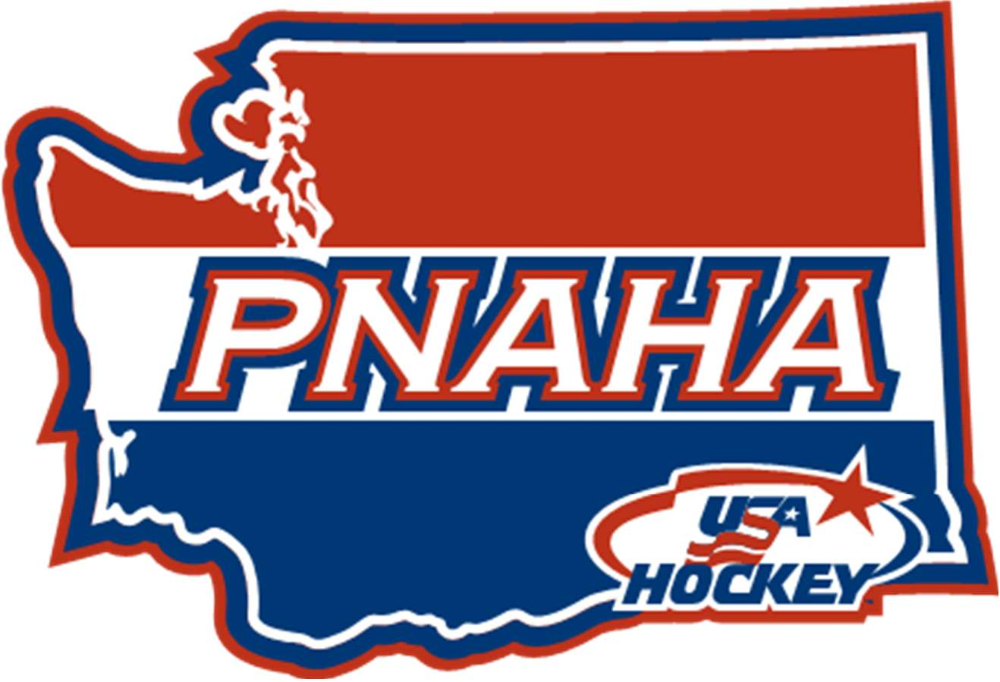

 |  |  | PNAHA Treasurer Report
 |  |  | September 19, 2020
 |  |  | As of August 31, 2020
Beginning Balance as of May 31, 2020 |  |  |  |  | $ 168,526.74
 | Income
 | Player Fees |  |  | $ 24,075.00
 | Total Income |  |  | $ 24,075.00
 |  |  |  |  | $ 192,601.74
 | Expenses
 | Misc Expenses |  |  | $ 2,077.41
 | Bank Fees |  | $ 10.50
 | Misc |  | $ 216.11
 | Office/General Administrative Expenses |  | $ 174.80
 | Storage |  | $ 575.00
 | Website |  | $ 1,101.00
 | Player Development |  |  | $ 732.77
 | Total Expenses |  |  | $ 2,810.18
Ending Balance as of August 31, 2020 |  |  |  |  | $ 189,791.56

 |  | 2020-2021 Proposed PNAHA BUDGET
 | 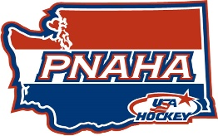
REVENUE
 | Grant Funds |  |  | $ 24,000
 | USA HOCKEY REGISTRATION FEE |  |  | $ 82,000
 |  | ($15 PER 7U+ YOUTH PLAYER, $5.00 PER ADULT)
 | PNAHA DEVELOPMENT CAMPS (Player Registration Fees) |  |  | $ 35,000
 |  | TOTAL INCOME |  | $ 141,000
EXPENSES
 | ADM Director East/West (Travel, Expenses) |  |  | $ 1,500
 | COACHING DIRECTOR (Travel, Expenses) |  |  | $ 1,500
 | Female Reprentative (Travel, Expenses) |  |  | $ 1,000
 | Goalie Director East/West (Travel, Expenses) |  |  | $ 3,000
 | LEGAL & PROFESSIONAL |  |  | $ 3,500
 | MEETINGS - ROOMS AND CATERING
 |  | CATERING/FOOD |  | $ 3,500
 |  | ROOMS |  | $ 6,200
 | Misc Expenses |  |  | $16,260
 |  | ADVERTISING/GIFTS/MISCELLANEOUS EVENTS | $ 2,500
 |  | BACKGROUND CHECKS (Exec Board/Appointed Dir) | $ 400
 |  | BANK CHARGES | $ 50
 |  | CELL/TELEPHONE/Conference Lines | $ 400
 |  | EQUIPMENT | $ 1,000
 |  | GRANT 10% to Pacific District | $ 3,500
 |  | INSURANCE | $ 210
 |  | Office/General Administrative/QuickBooks | $ 2,000
 |  | POSTAGE/SHIPPING | $ 1,000
 |  | PRINTING | $ 1,000
 |  | GUIDEBOOK Printing | $ 2,500
 |  | STORAGE FOR RECORDS | $ 700
 |  | WEBSITE | $ 1,000
 | PACIFIC DISTRICT PLAYER FEES |  |  | $ 16,800
 | PACIFIC DISTRICT SELECT CAMP FEE ($50/PLAYER ~64 Players) |  |  | $ 3,600
 | PNAHA PLAYER DEVELOPMENT CAMPS |  |  | $ 35,000
 | PNAHA League Banners |  |  | $ 1,000
 | PNAHA MEETINGS EXEC/DIRECTOR (Travel, Expenses) |  |  | $ 5,500
 | REFEREE Expenses |  |  | $ 3,000
 | SAFESPORT COORDINATOR (Travel, Education, Expenses) |  |  | $ 2,500
 | Showcase High School Team (Youth/Female) |  |  | $ 3,900
 | TOURNAMENT EXPENSES
 |  | ADULT Tournament (proposed) |  | $ 5,000
 |  | TIER I |  | $ 1,500
 |  | TIER II |  | $ 1,500
 |  | FESTIVAL 10U/12U |  | $ 1,500
 |  | B |  | $ 1,500
 |  | PNAHA STATE Tournament BANNERS |  | $ 1,500
 | TRAVEL - USA - SEMINARS |  |  | $ 10,000
 |  |  | TOTAL EXPENSES | $ 130,260
 |  |  | EXCESS / (SHORTFALL) | $ 10,740

