Raider Baseball Throwing Progression
The Raider Throwing Progression needs to be done before every practice and game. Create consistency every day going through each step and checking for proper mechanics for every throw.
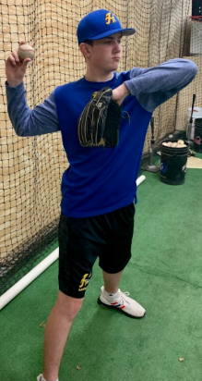
Top Half – 10 - 15 Reps @ 20ft
- Four Seem grip
- Toes pointed at partner
- Rotate Top Half – Keep lower half still
- Point Front Elbow at Partner – Back Elbow is below shoulders
- Elbows and shoulders create a 30 degree angle in a linear line
- Pinch Shoulder Blades together
- Turn and Throw in full time motion

Jump Backs – 10 - 15 Reps @ 30ft
- Toes pointed at a 90 degree angle from partner
- Hand/baseball in glove (Like the set position in the stretch while pitching)
- Jump Back into a “Load” position, loading into your back heel and back hip separating baseball/hand from glove (When in the “Load” position, your top half should look like the “Top Half” stage you took your first reps in)
- Explode from the “Load” position and throw making sure to follow through with heel to sky
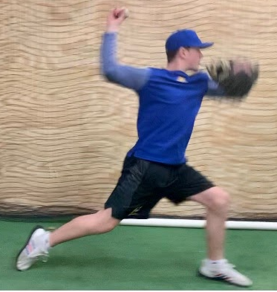
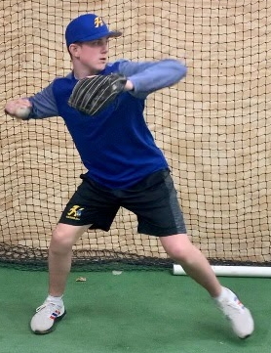
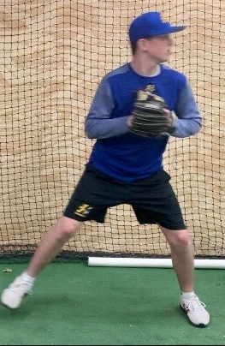
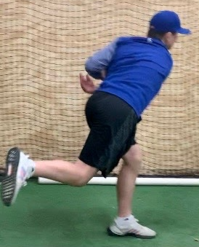

Shuffle and Throw – 10 – 15 Reps @ 60ft
- Toes pointed at a 90 degree angle from partner
- Hand/baseball in glove (Like the set position in the stretch while pitching)
- Shuffle feet forward getting into the “Load” position.
- Leads into the complete throwing motion
- Check that the kids are following through
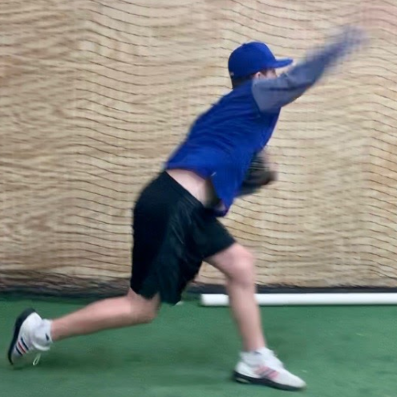
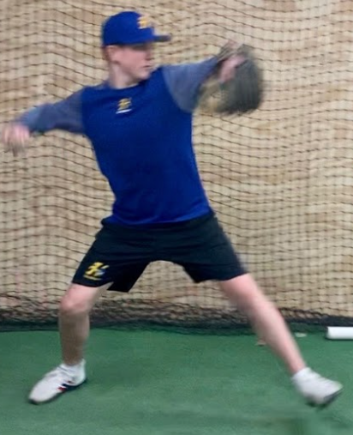
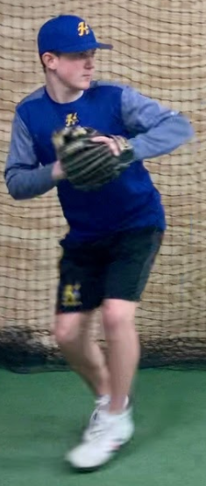
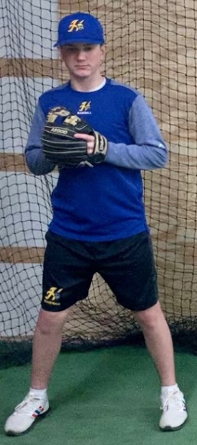

Long Toss – Reps depend on time of season
- Play catch from last stage to this stage, stretching it out as far as your arm allows
- Crow hop out, not up!
- Step and throw with more momentum, under control
- Flat throws, no rainbows
- One hop or two hop if needed
- Easy, fluid motion (No strain)
- Check for follow through, under control
Spot Drills – 10 Reps
- One kid is the pitcher, the other the catcher
- Best of 10 on hitting their spots
- Focus on mechanics, 60% speed (Balance point, bending over, release point, hit your spots!)
- Pitchers can work on change-ups
- Loser does pushups

