SLPYHA Board Meeting Agenda
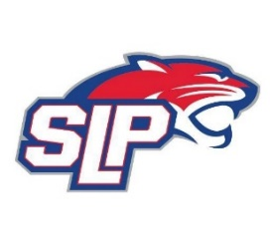
Date: 11/2/22
Bricks
7:00pm

Attendees: Scott Lichter, Mike Mliner, John Pitzl, Jon Tranby, Mike Fitzpatrick, Pat Cleary, Justyn Cowman, Adam Kiedrowski
Guests: Jess Scott (Golf Tournament Director), Isaiah Schoeman (Panther Classic Tournament Director), Dan Riley (Ice Scheduler)

- President Report: Scott Lichter
- Call to order: 7:21pm
- Approve agenda
- Approve minutes from 9/8/2022, motion: Lichter move: Pitzl
- Latest D10 updates
  - Mouthguards
- Waiver Sign-off
- 3rd Jersey Order - Sponsorships
- Golf Tournament – Jess Scott
  - Survey
  - Next year
  - Silent auction – order parking sign
- Pictures – Select vendor / schedule (Brooke Mastro)
- Coaches apparel - $100 rebate for all traveling, mite A & B
- Panther Classic 40th Anniversary
  - Dibs
  - On site Apparel
  - GameSheet
- Ice Scheduler – Dan Riley
- Vice President Report: John Pitzl
- Treasurer Report/Gambling Report: Mike Mliner
  - Board signage at Fogerty
  - September gambling report - $12k transfer to hockey account
  - Board approves monthly gambling expenses
- Secretary Report: Justyn Cowman
- Traveling Director Report: Adam Kiedrowski
- Girls Traveling Director Report: Kevin Mitties
- Mite Director Report: Mike Fitzpatrick/Pat Cleary
  - SLP Jamboree is open (A, B, C & D levels)
  - Evaluation - review
- Player Development Report: Jon Tranby
  - Cutting Edge Performance – Katie
- New/ongoing Business:
  - In-Season Goalie Training
  - SLPYHA Venmo Account?
- Motion to dismiss: 10:17pm, motion: Lichter move: Tranby

