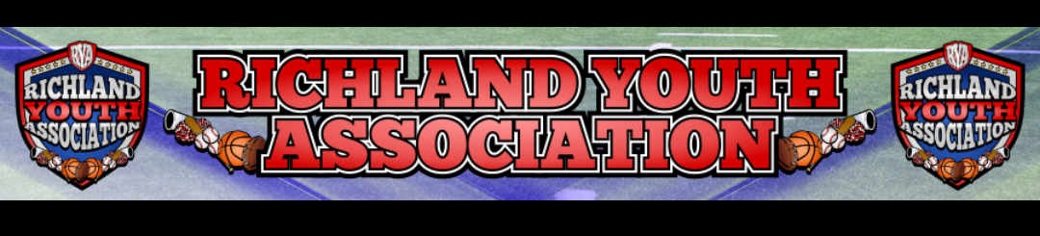
RYA February 2023 BOARD MEETING
Meeting Date: February 8, 2022 – 6:44pm
Board Member Attendees: Ben Earley, Richard Stutheit, Lisa Willis, Erica Stutheit, Emily Standifer, Eric Gomez, Kevin Vorpahl
Absent: Mike Cowan, Blair Armfield, Brandon Lewis
Non-Board Attendees: Thomas Schulz

General Board Items / Old News
- Fun Run at Smithfield Elementary is March 9th and sponsors are due on February 14th.
  - Banner being ordered from America’s Best – 4’x6’ with 1-week turnaround.
  - Vote approved with 7 yes and 2 absent.
- City Parks and Recreation Presentation on Feb 6th went well. City seems receptive to requests and comments that we made during the presentation.
- Convicted individual owes more than $11 thousand and judge extended her to February 2024.
- September-October lights were $5,680.21 and November lights were $2,663.96
- Registrations opened for Super Kids through April 1st and not sure when the season will start and end.

Basketball: Blair Armfield (absent)
- Pictures were done and fundraiser of $635 coming back to RYA.
  - Parents getting them in mail soon.
- End-of-season playoffs coming up on March 4th.
- The Link will be getting partial reimbursement due to cancellations.
  - Games were rescheduled to Richland Middle School and Link covering the charge.

Rec Baseball: Richard Stutheit
- Registrations Closed Out on 2/5 and with late registrations, we have 324 active players.
  - 6u is full and 8u is filling up.
    - Multiple kids on waiting list for 6u.
  - Late registrations are on case-by-case basis.
  - Expansion teams possible in 6u and 8u if coaches step up prior to Saturday.
- Fan Store Options – Rover9 and Keller Sports Store are two of the companies we’re looking at.
- Drafts are this weekend following Player Look on Saturday morning.
  - Practices will start on March 1st using the fields at Richfield and Cross Timbers Parks.
  - All teams have a head coach staffed at this time.
- Repairs starting next week on Richfield #2 backstop.
- Opening Day is on Saturday, March 25th and all teams will be home at Richfield Park
  - Working with Emily to get vendors and guests set up to attend Opening Day.
Premier/Tournament Baseball: Kevin Vorpahl
- Four tournaments scheduled for Spring season are scheduled.
  - 10 teams signed up already for May tournament.
- Premier League has multiple teams signed up across various age divisions.
  - One 8u, two 9u, two 10u, one 11u, three 12u, two 13u, two 14u
  - 10u team and three 13/14u teams using practice fields.

Football: Eric Gomez
- 7-on-7, two 10u teams and one 8u 5-on-5 team
- NWTYFA – MYFA conversations
  - Possible merger between these two organizations
  - RYA, Saginaw, Burleson, Lake Worth, and Granbury are looking at joining MYFA.
  - Benefits would be money saved on referee fees and less driving on parents.
  - February Meeting w/ NWTYFA on 2/19
- Registrations possibly opening for Fall Football on March 1st after merger talks are done.
  - Early Bird $150 (March), Regular Rates $175 (April-May), Late Rates $200 (June-July)
- End-of-season dinner has been prolonged issue and not happening due to scheduling conflicts.
  - 12u players will receive their Letter Jackets regardless of dinner.

Cheer: Lisa Willis
- Pricing out items now for Fall Cheer and would like to open the registrations at same time as football.
  - Uniforms at Tira Alterations would be $90/uniform.
  - Pricing will continue to open registrations by March 1st.

Marketing: Brandon Lewis (absent)
- No information.

Communications: Erica Stutheit
- Building football and cheer registrations on SportsEngine.

Special Events: Emily Standifer
- Baseball Opening Day – March 25th
  - Food trucks – Donut truck and Mr. Softee Ice Cream truck contacted.
  - Mayor unavailable, but councilperson could do First Pitch
  - 3 Bounce House companies contacted:
    - 2 BH, 1 Giant game, cotton candy - $475
    - 1 BH, 1 BH with slide, 1 Obstacle course - $500
    - Jericho Jones Bounce Houses to be contacted tomorrow.
  - NRHPD Honor Guard contacted and waiting for confirmation.

RYA Bank Accounts totaled $45,056.01 and $628.30 – combined total of $45,684.01

Meeting adjourned at 9:02 pm

