Local Art Students Volunteer Their Time and Talent to Enhance Mitchell Park; Scholarship Awarded
Bethel, CT (July 2021)
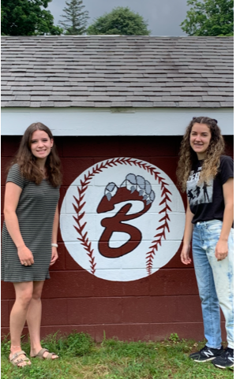
In addition to the regular efforts of the Bethel Parks and Rec Department, the Bethel Baseball Association (BBA) regularly finances and coordinates projects to maintain, enhance, and improve the baseball fields and facilities at Mitchell Park. Recent projects included turfing the battings cages, installing new audio systems, park clean up days, and many others. Their efforts were acknowledged in a formal letter of gratitude from the Bethel Parks & Rec Commission to the BBA members. An excerpt from this letter stated “…the BBA has transformed Mitchell Park into the finest youth baseball facility in the State, drawing thousands of visitors from throughout Western Connecticut and beyond…”*
In discussing the topic with BBA Treasurer Scott Beverly, he commented that “BBA hosts tournaments and games regularly and teams from all over the state come to play on our fields. We are always told how amazing the facility is and how it is such a great place for the kids to play the game of baseball. We, along with the Bethel Parks and Recs Department, take a lot of pride in Mitchell Park as have the many players, coaches, and league officials who have cared for it before us.”
These non-taxpayer funded projects are only some of the many that the all-volunteer baseball organization and its sponsors have contributed to the facility. So this Spring’s complete repainting of the eight dug outs was not particularly unusual. The completed job looked clean and fresh, but Scott was tossing around an idea to add something more. A logo or design on the back of each dugout would only further enhance and contribute to the overall character of the park. But how to do it in a way that was professional, sustainable, and affordable?
While discussing the idea with friend and Board of Education member Courtney Martin, the suggestion to engage the artistic talents of the local high school art department was formed. Courtney reached out to Principal Chris Troetti who engaged the Coordinator of Art K-12, Rebecca Lacey. Within a matter of weeks, Brooke Brescia and Kasey Germinaro, two of Bethel High School’s artistically talented and creative students, were at Mitchell Park ready to lend their skills to the endeavor. They hand sketched and painted the BBA logo on the back of each of the 8 dugouts over the course of many hours of volunteer efforts. The logo is fairly detailed and consists of a baseball with stitching in the background and the BBA’s Maroon script “B” with its Wildcat mascot’s paw reaching over it. The finish project was remarkably done with no attention to detail spared.
Principal Troetti said of the efforts “We are always excited to collaborate with and support community organizations. There are so many talented artists at BHS, and we are thrilled they were able to provide this service for the BBA.”
The Board of the Bethel Baseball Association would like to thank Principal Troetti, BOE Member Courtney Martin, Mrs. Lacey and, in particular, Brooke Brescia and Kasey Germinaro for their time and efforts on this project. As a sign of their sincere gratitude, BBA will be donating $500 to the Bethel High School Art Department Sarah Esposito Scholarship.

About Bethel Baseball Association:
Bethel Baseball Association is a Bethel, CT volunteer run organization that offers children the opportunity to play baseball at the Cal Ripken level (T-ball – 4-year-olds through Majors – 12 year olds) and Babe Ruth (13+ year olds).
About Mitchell Park:
Mitchell Park is located on Old Hawleyville Rd in Bethel, CT and consists of 4 baseball fields (Leonard, Slifkin, Pullan, and Cleary) in addition to a BMX Supercross track.

*Full Letter from the Parks and Recreation Commission to BBA available upon request

