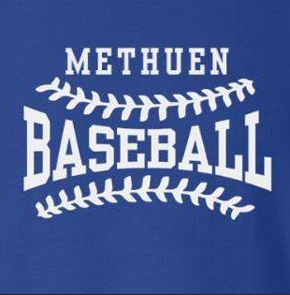

Meeting Agenda November 2, 2022
Attendance:

- Umpire Special speaker 15-20 minutes

- Vote/ Approve Meeting Minutes from last meeting. 2-5 minutes

- Treasurer Report 3-5 minutes

- Cal Ripken VP Report 3-5 minutes

- Babe Ruth VP Report 3-5 minutes

- Fundraising/ Sponsorship Report 5-7 minutes
  - Sponsorship packages and pricing
  - Fundraisers/ Music Bingo

- Umpire in Chief Report 3-5 minutes

- Equipment Manager/ Uniforms Report 3-5 minutes

- New Business/ Website / Registrations 3-7 minutes
  - Who is authorized to waive sign up fees

- Tryouts/ Gym Updates 3-5 minutes

- New Balance Proposals/ Clinics 7-10 minutes

- Working with Methuen High School 2-3 minutes
- Running clinics for us
- MYB participating with high school for home games

- Updates on Santa Parade 3-5 minutes
- Sub committee/ volunteers/ candy/ decorations

- Festival of Trees Update 3-5 minutes
  - Sub committee/volunteers/ decorations

- Closing the Huts 2-3 minutes
  - Sandlots are done/ Plumber ?

- Any more new Business/ Old Business

Adjourn.

