SPORTS INTERNSHIP OPPORTUNITY
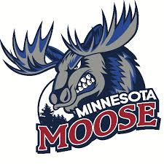
Minnesota Moose, United States Premier Hockey League
Part Time & Full Time
Offseason (May-Sept)
Half-Season (Sept-Dec; Jan-May)
Full Season (Sept-May)

The Minnesota Moose Hockey Club, are moving in to the Fourth year of operation and are looking for motivated, passionate interns to assist with operations during the 2020-2021 season. Moose internships are full-time or part-time and allow students the opportunity to gain valuable work experience within a sports organization through hands-on experience. A successful applicant will demonstrate strong organizational skills along with initiative, resourcefulness, and an ability to collaborate with team members for the achievement of team goals. In past years, interns working with Jr. A hockey teams have been successful in securing full time positions across a wide field of industries post-internship. Career mentoring is a central aspect to the Moose internship program.
Account Executive Internship
Client Sales, Office Management, Community Relations, Game Night Operations, Fan Experience
- Responsibilities
  - Maintain ongoing target list and complete sales calls to secure group outings
  - Sell group tickets and ticket packages
  - Answer inbound calls
  - Assist with ticketing during home games
  - Provide customer service
  - Serve as Moose liaison at community events
  - Maintain ticket sales files and complete important client data entry
- Qualifications
  - Exceptional customer service skills
  - Self-starter and highly motivated
  - General knowledge of Microsoft Office and Google Documents
  - Effective and engaging communicator
- Compensation
  - 7% commission on ticket plan and group ticket sales
  - School credit available in accordance with school and program qualifications

- To apply, please send cover letter and resume to mnmoosecoach@gmail.com

Jon Jonasson
Head Coach/ General Manager
952-457-0525
mnmoosecoach@gmail.com

