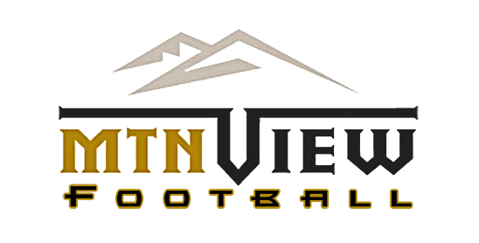

2022 STADIUM AD Sponsorship
The Mountain View High School TD Club is currently accepting applications and payment for our 2021 advertising. Your Ad Board will proudly be displayed around Mtn View Community Stadium from August 2022–July 2023. Please include your Layout in camera ready Artwork at 300 dpi or Larger and send to mtnviewtdtreas@gmail.com
Advertising Stadium Banners Pricing
___ Sideline A-Frame – only $500.00
~OR~
___ 3’x 5’ Fence Banner – only $350.00

- Please make checks payable to MVHS TD Club
- Please contact Michael VanHorn at mtnviewtdtreas@gmail.com
OR 404-655-1707 for more information

Company Name___________________________________ Company Hashtag_______________________
Company Address____________________________ Company Phone Number:_______________________
Company E-Mail Address:_________________________________@__________________________
AD Taken by:_________________________ Check Number_____________ Check Amount:______________
MAIL TO:
Mountain View High School Touchdown Club
PO Box 492109
Lawrenceville, GA 30049
Thank you for supporting the Bear Nation!

