Tonka Wrestling Communications
Face to Face:
Good old Fashioned face to face. After 5pm in the wrestling room during regular practice days, and after events. This is the best forgotten form of communication in today’s digital age.
Email/Phone:
- Coaches
  - Josh Frie (Head Coach):
    - Email: josh.frie@mtka.org
    - Phone: (612) 865-9303
  - Joel Schrimpf (Assistant Coach): joelschrimpf@tonkawrestling.org
  - E. J. Shelby (Assistant Coach): enrico.shelby@minnetonkaschools.org
  - Nick Gabler (Assistant Coach): nsgabler@iastate.edu
  - Kyle LeDuc (9th Grade Coach): kyleleduc157@gmail.com

- General Communications: minnetonkawrestling@gmail.com
- Website: “Tonka Wrestling” no-reply@sportsengine.com

Website: http://www.tonkawrestling.org/
Each family must register and add the parent emails during registration to ensure communications are delivered to everyone in the family.
Invitation emails will go out after the PAC.
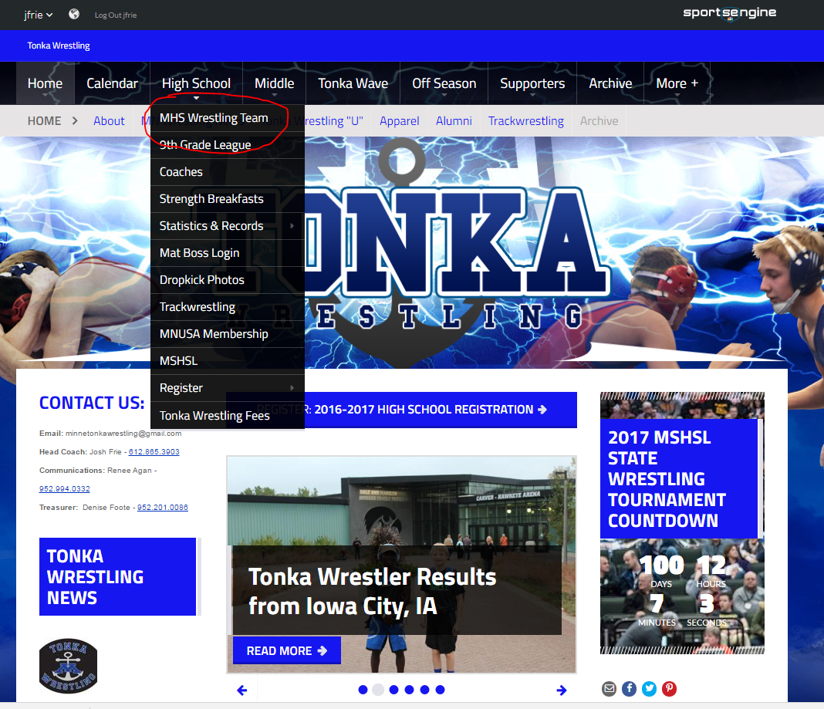
#4: Sign up for events and Volunteer with “Sign Up Genius” here throughout season
#1: Log in here. May need to create a sportsengine profile.
#2: Register with website here
#3: Get MHS information here
Calendar:
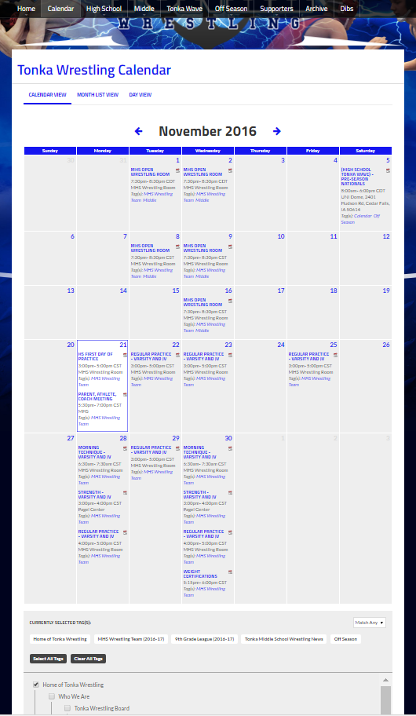
#2: Select Desired Tags
#1: Select Calendar
iCalendar Feed:
With the proper tags selected you can link the schedule to your calendar software of choice as follows.
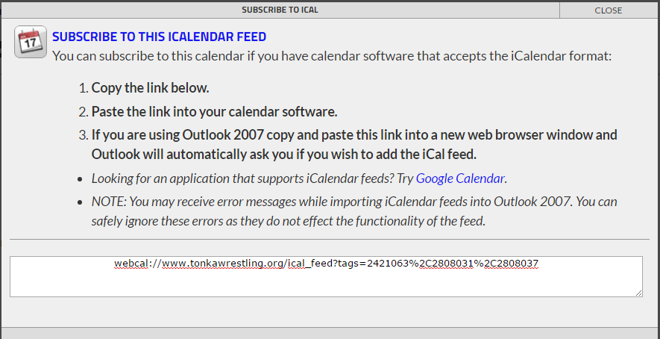
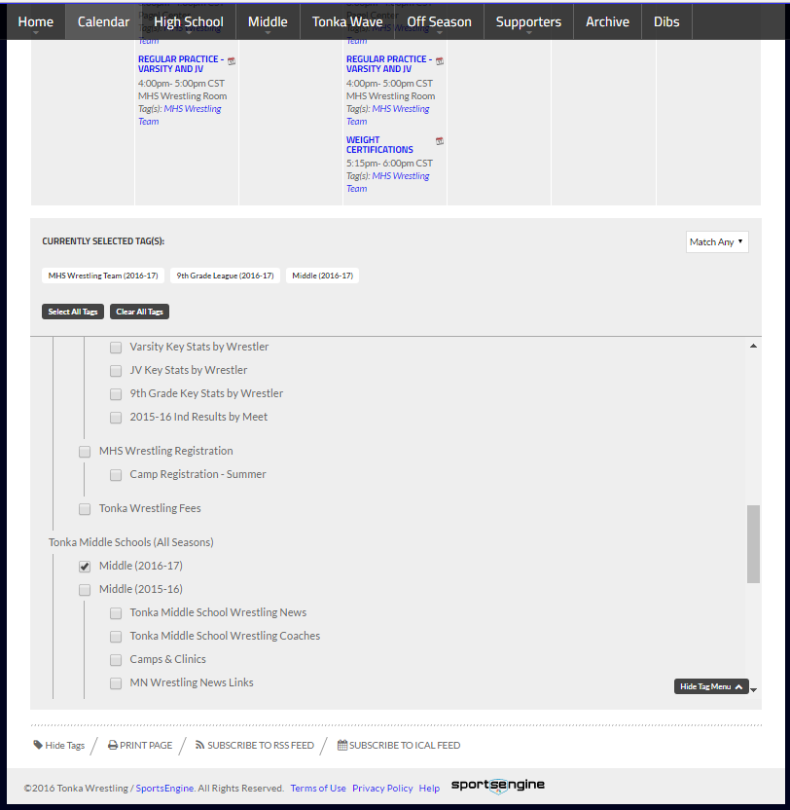
#3: Click subscribe to iCal Feed and follow instructions

App:
- Download “sportsengine” app from the apple or google stores

- If asked, allow push messaging so you get notifications on your phone when schedule changes news articles, or other important messages are sent out.

- Search for “Tonka Wrestling” and star the MHS wrestling team
  - 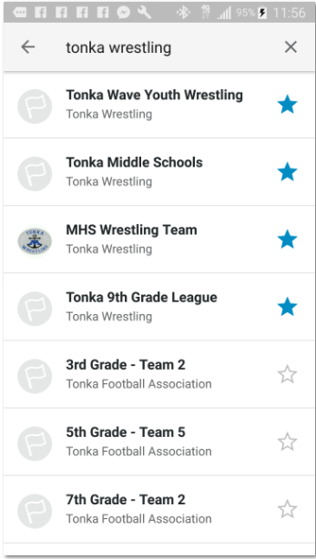
- To configure push notifications later on, use the flow below.
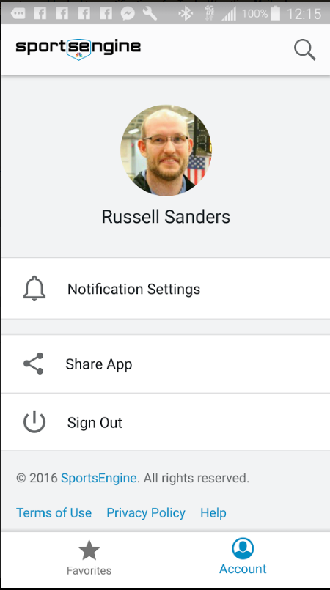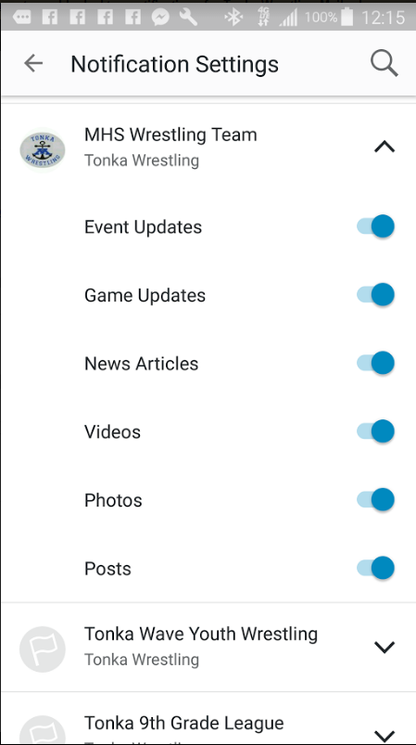

Social Media:
“Tonka Wrestling” and “Tonka Wrestlers”
  - Tonka Wrestling is meant for everyone and managed by the parent’s group
    - 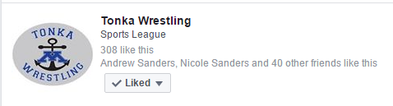
  - Tonka Wrestlers is meant for wresters and alumni
    - 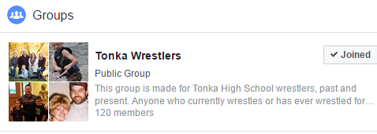
 #TonkaWrestling and #Tonka_Wrestling
  - #tonkawrestling is meant for everyone and managed by parents group
    - 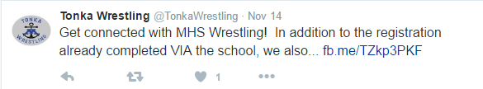
  - #tonka_wrestling is meant for wrestlers/everyone and managed by Captains
    - 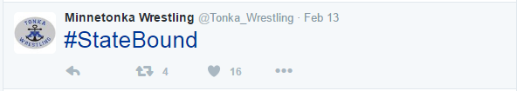
Other Wrestler Led Systems:
- Determined by wrestlers, but traditionally has been “Group me”

