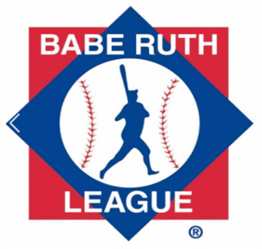

Meeting Agenda April 7, 2023 6:00pm Neil Playstead
Attendance:

- Vote/ Approve Meeting Minutes from last meeting. 2-5 minutes

- Treasurer Report 3-5 minutes

- Cal Ripken VP Report- update on umpires / Sunday clinics 3-5 minutes
  - 12 U District tryouts
  - Summer ball

- Babe Ruth VP Report- 3-5 minutes
Summer ball
Need team photos for sponsor plaques

- Fundraising/ Sponsorship Report 5-7 minutes
  - Summer Sponsors? 1 Sponsor refunded for uniform error, not our fault.
  - Merchandise in stock – update, Team Store/Dan Touma Designs
  - Movie Night out
  - New Hampshire Fisher Cats Game-order more tickets?
  - Fall Music Bingo Event

- Equipment Manager/ Uniforms Report 2-3 minutes
  - Pitching Machines for Bambinos-3 needed at approximately $175 each
  - 2 L screens in Neil Parking Lot Shed/ fix or replace L Screens for Vets
  - Trophies- get pricing and order- pricing updates
  - Purchasing cheaper practice balls for coaches
  - More catchers gear will be needed to replace the Velcro sets from last year
  - Need to start replacing older catchers mitts.
  - Order baseballs for Summer ball.
  - Other equipment needed?
  - Summer/District Uniforms- Fitted hats, trying for 2 button shirt if in stock.

- Food Huts 5-10 minutes
  - Create shift schedules- Updates?
  - Health Inspection- updates
  - Change Locks on outer doors- completed
  - Bathroom at Vets repairs
  - Neil roof repaired/bathroom ceiling fixed/city getting quotes to redo roof.
  - Paint the huts- pick a date

- JR Home Run Derby/Pitch Hit Run
  - Pick a date
  - Grill for the league use.

- Bambino Buddy Ball Program 2-3 minutes

  - First Game now May 7/ open Hut?

- Field Maintenance 3-5 minutes
  - Need to start replacing safety fence topper at vets, city said its on us.
  - Tool to install fence topper $75.
  - Put combo lock on neil parking lot shed for coaches access to chalk, line machine?

- Summer Registrations 3-5 minutes
  - Open registrations- registrations are open
  - Created Coaches registration.

- Year end awards
  - Banquet yes or no, if no handing out trophies night of championship games
  - T shirts for all players year end gift- softball does this. They were about $4 a shirt.

Adjourn.

