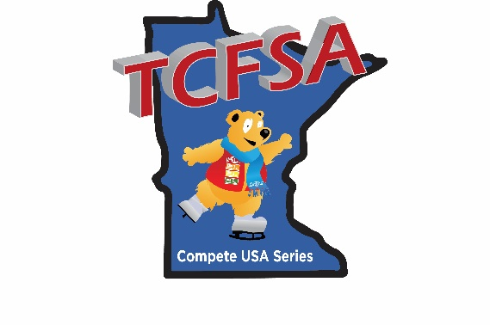
TWIN CITY FIGURE SKATING ASSOCIATION
COMPETE USA SERIES

TCFSA COMPETE USA SERIES MISSION STATEMENT: The series aims to promote an introductory competitive experience for the beginning TCFSA member skaters, allowing them to develop U.S. Figure Skating basic skills in an enjoyable environment. The Twin City Figure Skating Association (TCFSA) Compete USA Competition Series is sponsored solely by TCFSA and is a U.S. Figure Skating-approved Basic Skills Series. Competition announcements and entry forms will be posted on the official website of each participating competition. COMPETE USA and ASPIRE skaters are automatically registered and will have the opportunity to compete at 12 different local TCFSA member competitions to earn points for a final standing. Skaters MUST participate in at least two competitions to be eligible for an award. Awards will be presented to the top three skaters with the highest point totals in each level at the end of the series. Skaters competing in more than five competitions will use their five highest placements. Point accumulation information will be available at www.tcfsa.org in the COMPETE USA section. A team trophy will be awarded to the TCFSA member club that accumulates the most points during the season.

THE POINT SYSTEM: Each skater must be a member in good standing of a TCFSA member club. Each Basic Skills program event and Aspire Free Skate event in the series competitions will be eligible for points. The system for scoring points for the final standing will be as follows:
PLACE | POINTS
1 | 5
2 | 4
3 | 3
4 | 2

All competitors who place 5th or lower will be awarded one participation point. Per the U.S. Figure Skating Compete USA webpage, if there is only one skater in the group, he or she will be awarded three points. Additionally, if a skater advances to a higher level during the competition series season, their points will carry over to the next level. They will also be rewarded with two bonus points for moving up to a different level once during the series season and then one additional bonus point for moving up a second and third time, for a maximum of 4 points.

ELIGIBILITY and RULES FOR PARTICIPANTS: The TCFSA COMPETE USA series is open to all skaters who are current eligible members of either the Learn to Skate program or full members of U.S. Figure Skating through a TCFSA member club. Eligibility is based on the skill level as of the closing date of entries. All Snowplow Sam and Basic Skills skaters through Basic 6 must skate at their highest level passed and have NOT passed any US Figure Skating tests, including Skating Skills or dance tests. Males and females may be placed in the same group. The competitions in the series will be conducted under the rules set forth by the U.S. Figure Skating COMPETE USA and ASPIRE program. Skating levels included in the TCFSA series are Snowplow Sam, Basic 1 through Basic 6, and Aspire 1-4.

SCHEDULE of 2025-2026 PARTICIPATING COMPETITIONS*:

Competition | Host Club | Website | Month of Competition
Robin Lee | FSC of Minneapolis | www.fscmpls.org | August 2025
Mini-Champions | FSC of Bloomington | www.fscbloomington.org | August 2024
Maplewood Fall Classic | Maplewood FSC | www.mfscskate.org | September 2025
Hiawathaland | Rochester FSC | www.rochesterfsc.org | October 2025
Autumn Skate Festival | Burnsville MN Valley FSC | www.bmvfsc.org | November 2025
Skate in the Park | Three Rivers FSC | www.threeriversfsc.org | February 2026
Sunflower Classic | Lake Minnetonka FSC | www.lmfsc.org | March 2026
Star of the North | Chaska FSC | www.chaskafsc.com | April 2026
Rosebud Basic Skills | Roseville FSC | www.rosevillefsc.org | May 2026
June Bug | St. Paul FSC | www.spfsc.org | May 2026
Braemar Competition | Braemar City of Lakes FSC | www.braemarfsc.org | June 2025
*As of June 22, 2025

