WHS Summer Diving Clinic @OMS
COVID-19 Summer Activity Preparedness Plan

Validity
- South Washington County Schools may require a written mitigation plan for summer activities even when state requirements expire. Please check with your Activities Director for guidance.
- This template is valid and required from June 7th through June 30th, 2021, or until 70% of Minnesotans aged 16+ have received at least one dose of a COVID-19 vaccine.

Overview
- Staff members (Advisors, Coaches, Directors, etc.) are responsible for developing the plan that is approved by each Activity Office corresponding to the guidelines.
- The representative responsible for implementing the Plan must sign and certify the Plan, affirming their commitment to implement the Plan.
- Compliance by participants, parent(s)/guardian(s), and spectators is required.
- A copy of the plan must be available and able to be readily reviewed during the activity by staff, participants, oversight personnel, etc.

Recommendations to prevent the spread of COVID-19
- COVID-19 is primarily spread through respiratory droplets, so the risk of COVID-19 transmission increases when people gather together. Several key strategies can reduce the risk of getting sick or transmitting COVID-19:
  - Wear a well-fitting face covering.
  - Keep at least 6 feet of physical distance from other households.
  - Get tested.
  - Get vaccinated.

Requirements

1. Health Screening, Isolation, Quarantine, and Contact Tracing

Health Screening
- Enforce stay-at-home when sick policies for staff and participants.
- All staff and participants will be encouraged to report illness and/or exposure to ensure the safety of all.
- Home Screening
  - A daily self-report will be conducted prior to each day's session. Each staff member and participant or their parent will self-report current health to include:
    - temperature check (affirm they do not have a fever, of any temperature),
    - respiratory check (affirm they do not have a new cough and no shortness of breath/difficulty breathing),
    - exposure check (affirm they have not been in contact with a potential or diagnosed COVID-19 case), and
    - other symptom check (affirm they don’t have any other undiagnosed COVID-19 symptoms) MDH Decision Tree for People with COVID-19 Symptoms in Youth, Student, and Child Care Programs.
  - If anyone answers “yes” to any of these questions, they must stay home and follow the isolation precautions.
  - Be aware there are other illnesses than COVID-19. Any indication of illness should result in staying home.

Isolation
- The MDH Decision Tree for Schools will be followed to determine isolation/quarantine.
- Staff and participants who become ill during programming will be separated from activity and be expected to leave or be picked up as soon as possible.
- Any staff or participant who is exhibiting symptoms of COVID-19 (1 more common symptom or 2 or more less common symptoms) will need to be sent home or stay home for 10 days from symptom onset, unless they receive a negative COVID test or an alternative diagnosis. Day 1 is the 1st day after symptoms began.

Quarantine
- The MDH Decision Tree for Schools will be followed to determine isolation/quarantine.
- Any student or staff member who has been identified as a close contact (any person within 6 feet of a positive individual for 15 mins or longer cumulative in 24 hours) to a positive COVID case will be required to quarantine for 10 days from last exposure. Day 1 is the 1st day after exposure.
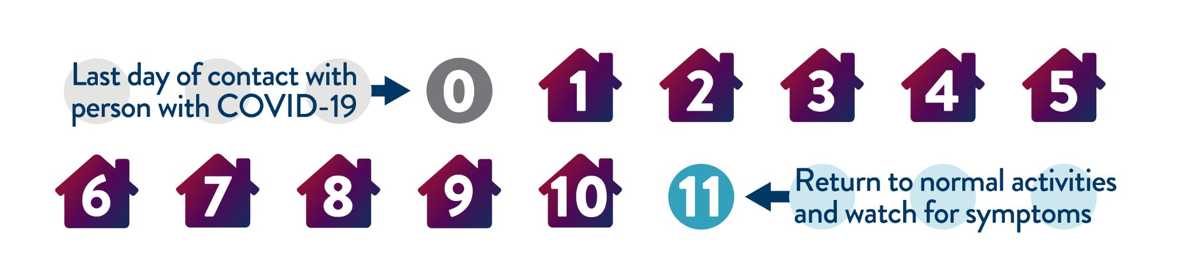
- 10-day quarantine considerations:
  - You have not had any symptoms.
  - You have not had a positive test for COVID-19.
  - No one in your home has COVID-19.
  - You do not live or work in a building where it's hard to stay away from others and easy to spread the virus to multiple people, like a long-term care facility.
  - Your contact with someone with COVID-19 had a beginning and an end. For example, your close contact happened at:
    - School
    - Sports event
    - Work
    - Social gathering
    - You traveled outside of Minnesota for reasons other than crossing the border for work, study, medical care, or personal safety or security, and all of the above are true. Note: Your "exposure" period ends upon arrival back home. For more information, see Protect Yourself and Others: Traveling.
- Staff members who are identified as a close contact or feel they have been exposed need to fill out a self-reporting form.
- Who will NOT need to quarantine: documentation will be required
  - If they have recovered from COVID-19 in the past 90 days AND
    - Illness was confirmed with a positive lab test,
    - They have fully recovered, and
    - They do not currently have any symptoms of COVID-19.
  - If someone fully vaccinated (two doses in a two dose series or one dose in a one-dose series) AND
    - The exposure was at least 10 days after their vaccination series was fully completed and
    - They do not currently have any symptoms of COVID

Contact Tracing
- If an activity has a positive COVID-19 case, close contacts will be determined based on the best information available from the program.
- Detailed attendance rosters are required.
  - Rosters allow more accuracy when determining close contacts and who needs to quarantine.
  - Records should capture the date, area used, staff, participants, and how they were grouped, including related activities such as in the weight room.
  - These records should be maintained for at least two weeks after the end of the activity and be available for review upon request.
- The definition of close contacts may be expanded to the entire program if there is no documentation or other ability to confirm attendance or interactions.
  - Expanded close contacts will likely result in the entire program being quarantined.
- If close contacts are determined, they will be notified via email.
- Coach Rick will take attendance each Wednesday 3-4:30PM at OMS diving well pool. He will share attendance with Coach Liz. Both Coach Rick and Coach Liz will maintain attendance records for the WHS Summer Diving Clinic.
2. Hand Hygiene
- Staff and participants will:
  - Wash hands often with soap and water for at least 20 seconds, especially after having been in a public place or after blowing your nose, coughing, or sneezing.
  - If soap and water are not available, use a hand sanitizer that contains at least 60% alcohol.
  - Always cover your mouth and nose with a tissue when you cough or sneeze.
  - Throw used tissues in the trash. If you do not have a tissue, cough or sneeze into your arm or elbow.
- Staff and participants will wash hands upon arriving, before and after eating meals, before and after applying sunscreen, and when entering or leaving indoor spaces.
- Hand sanitizer and tissues will be readily available for use.

3. Cleaning and disinfecting
- All surfaces and equipment will be sanitized at the end of each activity by activity staff.
- Each activity will have paper towels and spray sanitizer on hand for equipment and surfaces.
- Indoor areas will be cleaned at the end of each day by custodial staff.
- Seed and gum spitting is strictly prohibited on school property.

4. Face coverings
- Under current state and CDC guidelines, face coverings are required on all public transportation, including district buses and other provided transportation.

Compliance
- All staff must be in compliance and follow the guidelines set forth by SoWashCo Schools, the Minnesota Department of Health, the Minnesota Department of Education, and the Centers for Disease Control.
- Participants in the activity must follow the plan for the program. Activity staff will reinforce COVID-19 protocols at all levels during the program.
- In the event a participant is non-compliant, they may be told to take time off and return when and if they are able to follow the guidelines for the health and safety of all.

By signing this form, you agree to follow all protocols outlined above for COVID-19 compliance. As a staff member working for a school district all applicable district, MDH, MDE, and CDC guidance recommendations for providing programming must be followed and enforced. Copies must be available for participants and/or families. In the event of non-compliance, the program will not be able to participate and compensation for the remainder of the program will be reviewed.

Activity Staff Lead
Name (print): Rick Light
Position (print): Diving Coach
Signature: Rick Light
Date: 6/8/21

Additional Activity Staff
Name (print): Liz Rodgers Horan
Position (print): Head Swim & Dive Coach
Signature: Elizabeth H. Rodgers Horan
Date: 6-8-21

Additional Activity Staff
Name (print):
Position (print):
Signature:
Date:

