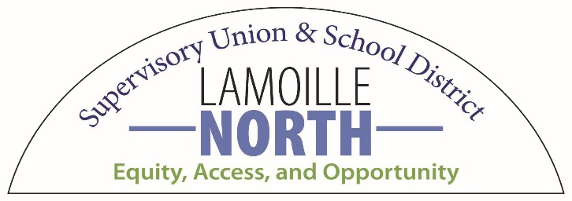
Lamoille North School District
2021-2022 Winter Guidelines

Welcome to Lamoille North School District.
We are very excited to start this season with all of you as spectators for our home events. In the best interest of all in attendance, masks must be worn appropriately at all times throughout indoor games/events. Additionally, concessions will not be sold this season and no food or drink will be allowed in the gymnasium/facilities. We are all here to support and celebrate our students, teams, coaches and officials. Thank you all in advance for attending this event in a safe, respectful and sportsmanlike fashion. We are pleased to host spectators but need to remind the audience that the ability to do this is based on two conditions, appropriate mask wearing and the status of COVID 19 in our communities. Our guidelines can change at any time based on the dynamic nature of the pandemic.

Adults and students, as well as the participating student athletes are encouraged and expected to work together to ensure a meaningful and safe learning environment that allows our communities to grow and thrive together.

If the task of monitoring proper masking compliance and spectator conduct becomes a challenge to site administrators, Lamoille North School District, will be forced to host future games/events without spectators. Not properly wearing a mask will result in the removal of any spectator violating this masking requirement. Games may be paused until there is compliance with mask wearing and sportsmanlike behavior.

Important Community Reminders

- Doors will open no more than 30 minutes prior to the start of any game/event.
- Travel in our buildings will be limited to specific restroom and gymnasium access only
- All spectators need to leave promptly at the conclusion of all events/games.
- Fire Marshall Code determines gymnasium capacities for spectators. Attendance will be determined on a first come, first serve basis. Once capacity levels are reached, additional spectators will not be allowed entry.
- All spectators must be seated in bleacher areas and there will not be “standing areas”.
- There will be signs that identify seating sections. Spectators should take note of the section in which they are seated for purposes of contact tracing by the Vt. Dept. of Health. (Should it be deemed necessary?)

All gymnasiums should be entered through the gym doors. Please limit your impact and stay in the gymnasiums and or designated bathroom areas.

