Indian Creek
Battle at the Creek 2026
Sunday, January 4th
________________________________________________________________________________________________________________________________________________
Location:

Indian Creek HS Field House
802 S Indian Creek Dr. Trafalgar, IN 46181
Door 27E (back side of the school, no entrance from the front)
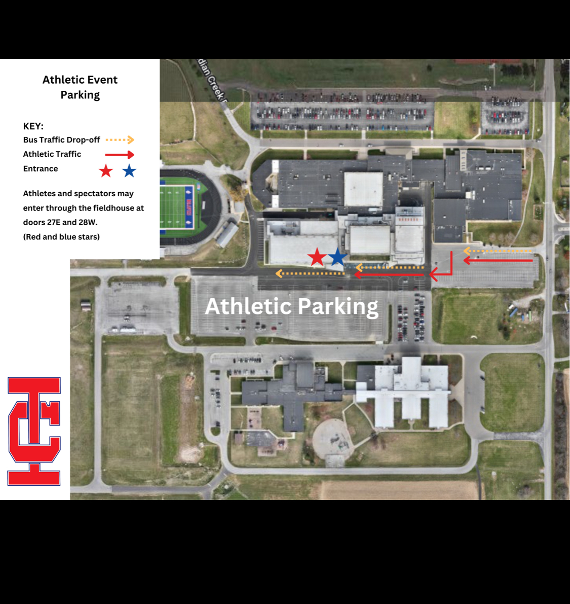
*PLEASE BRING LAWN CHAIRS

ENTRY FEE : $30
OPEN
Session 1: 6u, 8u, 10u
Doors open: 8a
Wrestling Begins: 9a

Session 2: 12u, 14u
Doors open: 12p
Wrestling Begins: 1p

Current USA Wrestling card required
Registration closes Saturday Jan 2, 2026 @1pm

SATELLITE WEIGH INS
Sanctioned club representative must send satellite weigh in by Saturday 1/2/26 @ 1 pm. Email icwcbraves@gmail.com A challenge fee of $10 will be paid to the tournament director, if a wrestler is 3lbs out of their weight class the wrestler is disqualified without a refund.

Awards
CHAMPIONSHIP PENNANT
Medals 1st-4th

Spectator fee: Cash or Card
$5 person (5 & under free)
$10 family
Coaches free with card
No USWA cards on site, purchase at www.usawmembership.com

Contact email: indiancreekwc@gmail.com

