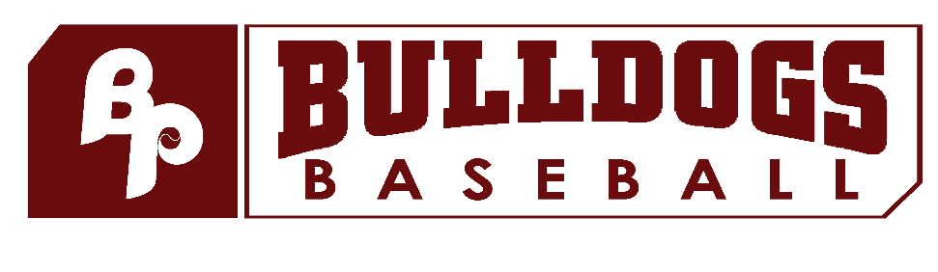
Brooklyn Park Bulldog 12u Cooperstown Teams
BPAA Cooperstown Corporation, a 501c3 nonprofit

BP Bulldog Invite Sponsorship Levels

PRESENTING Sponsor - $5,000 (Limit 1)
- 2026 BP Bulldog Invite presented by “your company”
- Concession signage featuring company logo at 3 tournament sites, May 15-17
- Option to place company-provided banner at each tournament location
- Logo with QR code on tournament banner displayed at each tournament site entrance
- Logo on team banners used for all tournaments
- Logo on tournament t-shirts
- Logo on sleeve of alternate jersey for each team
- Logo with link on tournament and Cooperstown team web pages
- Scheduled social media posts weekly through August 2026
- Sponsorship mentioned in all email communications to all tournament teams
- Ability to add a coupon or promotional material to team swag bags
- Named as preferred vendor (hotels, restaurants, etc.) on tournament info

GRAND SLAM Sponsor - $3,500 (Limit 5)
- Concession signage featuring company logo at 3 tournament sites, May 15-17
- Option to place company-provided banner at each tournament location
- Logo with QR code on tournament banner displayed at each tournament site entrance
- Logo on team banners used for all tournaments
- Logo on players warm-ups for full season
- Logo with link on tournament and Cooperstown team web pages
- Scheduled social media post at least bi-monthly through August 2026
- Sponsorship mentioned in all email communications to all tournament teams
- Ability to add a coupon or promotional material to team swag bags
- Named as preferred vendor (hotels, restaurants, etc.) on tournament info

HOME RUN Sponsor - $2,500
- Option to place company-provided banner at a single field at one tournament location (“field sponsor”)
- Logo on tournament banner displayed at each tournament site entrance
- Logo on players’ warm-ups used for full season
- Logo with link on tournament and Cooperstown team web pages
- Scheduled social media post at least monthly through August 2026
- Ability to add a coupon or promotional material to team swag bags
- Named as preferred vendor (hotels, restaurants, etc.) on tournament info

TRIPLE Sponsor - $1,500
- Option to place company-provided banner at a single field at one tournament location (“field sponsor”)
- Logo on tournament banner displayed at each tournament site entrance
- Logo with link on tournament and Cooperstown team web pages
- “Thank You” post on social media
- Ability to add a coupon or promotional material to team swag bags
- Named as preferred vendor (hotels, restaurants, etc.) on tournament info

DOUBLE Sponsor – $500
- Logo on tournament banner displayed at each tournament site entrance
- Company name with link on tournament and Cooperstown team web pages
- “Thank You” post on social media
- Ability to add a coupon or promotional material to team swag bags
- Lane sponsor for BP Bowling night at Sundance in February
- Named as preferred vendor (hotels, restaurants, etc.) on tournament info

SINGLE Sponsor – $100-499
- Company name with link on tournament and Cooperstown team web pages
- “Thank You” post on social media
- Ability to add a coupon or promotional material to team swag bags
- Lane sponsor for BP Bowing night at Sundance in February
- Named as preferred vendor (hotels, restaurants, etc.) on tournament information

