Nassau County Girls Soccer
Coaches Association
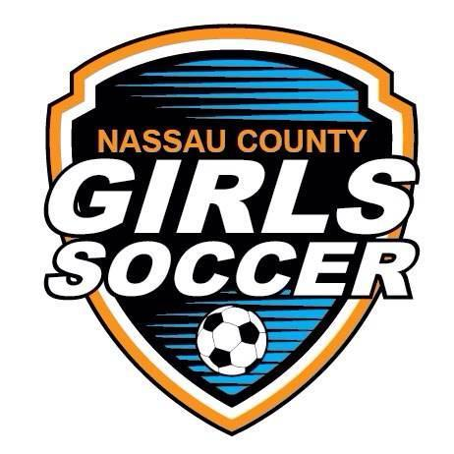
Journal Advertisements
All Star Awards Dinner
Honoring
Nassau County Girls Soccer Players
Rates

FULL PAGE $130
HALF PAGE $ 80
QUARTER PAGE $ 50
The undersigned agrees to take ____________ page space in the Program in honor of Nassau County Girls Soccer Players to be held on Monday, December 2nd, 2019.

Firm Name ____________________________________________________

Address ______________________________________________________

City _________________________________________________________

Solicited by ___________________________________(Player and School)

Email advertisement to: lbishar@gmail.com (emails will be forwarded to the printer as is and must be print ready) Please send in Microsoft word format or PDF file.
Hand written advertisement(s) will NOT be accepted, it must be print ready.

Make checks payable to: Nassau County Girls Soccer Coaches Association or (NCGSCA)

Mail Checks to: Lauren Brossard - 35 Pell Terrace, Garden City, NY 11530 (please include school/coach you are submitting Ad for)
DEADLINE:
Friday, November 1st, 2019

