Hutchinson Hockey Association
Annual Meeting & Awards
Tuesday March 12, 2024
Crow River Golf Club @ 6:30pm

- Agenda
Welcome
Awards
Team Updates
Financial Report – ,Treasurer
Gambling Recap
Nominations & Board Elections
Announcements/Notes
Election Results
Adjournment

Motion by Melissa C and second by Amada to adopt agenda – motion passed.

- Awards & Recognition
Outstanding Girl Player 10U: Kate Black
Ivan Hurt Award – Outstanding Squirt Player: Mason Orwoll & Kyrin Yerks
Kelby Macemon Award – Outstanding Peewee Player: Brecken Schweim
Outstanding Girl Player 12U: Josey Witte
George Tokarczyk Award – Outstanding HHA Bantam Defensemen: Carson Bridge
Keith Potter Award – Outstanding HHA Goalie: Cooper Neppl
Joel Starrett Memorial - Coach of the Year Award: Eric Katzenmeyer
John Darmody Award – Outstanding HHA Referee: Griff Hutchins
Dick Price Award – Outstanding HHA Member: Josh Knudtson & Dana Schmalz
New! HHA assistant Coach of the year – Justin Witte

Outgoing HHA Skaters
Boys
Ethan Block Isaac Johnson
Weston Borstad Lane Leibfried
Grady Campbell Rylan Michkolichek
Jack Hantge Braxton Schmidt
Grant Haglund Charlie Wacek
Logan Hagstrom Dylan Wagner

Girls
Lydia Bassett Izzy Katzenmeyer
Abigail Brandel Claire Katzenmeyer
Whitley Borstad Chesney Nelson
Elle Haglund Aubrey Mickolichek
Jozie Petersen Anna Schmalz
Ayana Kollar

USA Hockey Awards – Awards given in the following areas
- Zero Award – For a goalkeeper playing a complete game without allowing a goal
- Playmaker Award – For a player registering three assists in one game.
- Hat Trick Award – For a player scoring three goals in one game.

Coaches Awards – Presented by President Kati Katzenmeyer

Thanks to the members of the PDC
David Winn – Coach-in-chief
Ross Wendling Matt Telecky – HHS Coach Boys
Eric Katzenmeyer Andy Tufto - HHS Coach Girls
Josh Knudtson
Adam Kaping
Joel Reiter

If interested in being on the PDC see David Winn or Eric Borstad.

Mite Acknowledgment
Thank you to all Mite coaches, managers, and equipment manager for what you do for the kids involved in the HHA mite program.

Special Thanks
A special thanks to all the volunteer positions. It takes many people to make the HHA hockey program successful.

Thank you to all team managers!

Thanks to the HS hockey programs for being involved with the kids in the HHA program.

- Financials
*If you would like to see more on the financial health of HHA please reach out to Eric Borstad (President) or Miranda Wacek (Treasurer)

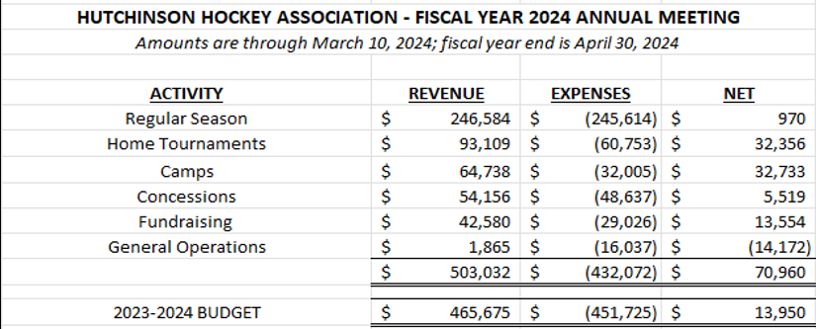

- HHA Gambling (E-Tabs)
Electronic pull-tab locations:
Muddy Cow
Oakdale Golf Course
River House (Both Levels as of March 1, 2024)
Total Gambling Income through Feb 2024 = $107,859

To date HHA has spent $105,709 in gambling revenues on the following
City of Hutch – Ice Fees
District 5 (Playoffs & Game officials)

- Elections
Thanks to the current board
Open floor for nominations (must be present to accept nomination)
- Write in results makes nomination from the floor for Director of Hockey Operations.
Positions open
Vice President, Treasuer,Tournament Director, Girls Rep, Director of Special projects.
Close Ballot
- 2024 Camps
Spring (6 weeks) March 10- April 25
Summer (6 weeks) June 11-27 -July 9-25
Pre-Season (4 weeks) September 3-27.

- Call for Volunteers
HHA runs on volunteerism
- Helps keep costs down
- Leadership positions
Largest impact on your skater
Start by being a manager, assistant coach, or organizing a recruiting/retention or fundraising event.
- Volunteers enable positive change
Great ideas are nothing without the will to work productively with others to see the through.

- Election Results
- Open – Vice President
- Adam Simantel – Tournament Director
- Melissa Campbell / Erin Knudtson – Special Operations
- Jessica Engelsmeier- Girls Rep
- Meranda Wacek - Treasurer

- Thank you to our 2023 – 2024 Sponsors
A complete list can be found by going to the HHA home page and selecting Sponsors

- Bylaw Changes – No bylaw changes

- Adjournment
Motion to Adjourn by Jess Engelsmeier / 2nd by Melissa Campbell – Annual meeting adjourned.

Email Vote on 3/13/2024 by Meranda Wacek and second by Josh Karg to pay February gambling bills. Motion carries to pay the bills.

