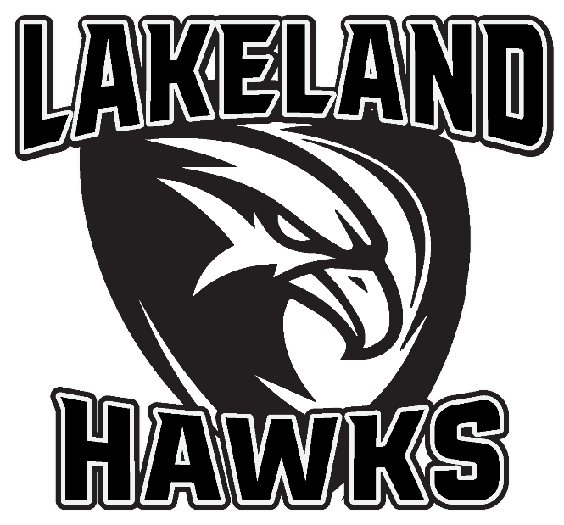

January 1st, 2020

Dear Sponsor,

Providing healthy youth activities and boosting tourism dollars in the greater Lakeland area are goals we all share. Thanks to the vision of businesses and organizations such as yours, the non-profit Lakeland Hawks Ice Arena was built in 1995 and has been home to hockey and figure skaters for the past 24 years. In that time, the LHIA has promoted positive, healthy activity for our local youth as well as hosting thousands of visitors: hockey teams, tournaments, development camps, and figure skating clinics and camps. Skaters and families from all around northern Wisconsin and the Upper Peninsula patronize our area hotels, shops and restaurants.

The outcome has been multiple State appearances at the youth hockey level, including our young players moving on to play at the State and National elite levels. We are proud to be the home and foundation of past and hopefully future NHL players. The Figure Skating program is sanctioned by the U.S. Figure Skating Association, and our skaters represent our club regionally at competitions such as Badger State Games and Upper Great Lakes Regionals, and nationally at State Games of America.

With all the success we have seen, the costs of keeping the arena open and running have increased substantially and many recent expenses have put LHIA in a very tough financial situation. Everyday expenses have risen, and after two decades, maintaining and replacing vital capital items such as compressors, heating systems, and the Zamboni have combined for over $100,000 in costs.
LHIA is a 100% volunteer-run organization, with only a single employee. Our hard working rink manager does more with less than many other ice arenas, including his own salary. Our skaters and families contribute program fees and volunteer hours, sometimes far more than other area rinks. And thanks to organizations like you, the dedicated fundraising team raised over $49,000 in 2018/19. We couldn’t do it without you, but the ice arena needs your help.
We are proud of the small town support of this facility and that together, we provide healthy youth activities for our area. Your continued support is necessary to keep the arena doors open for area youth and visiting skaters. Please see the attached sponsorship form for options that work for your organization, as well as a copy of the rink’s financials. A Board sponsorship is a highly visible way to show local families and visitors that your business supports youth skating. All BOARD sponsors will receive a public thank you and season passes to the High School home games, as well as announcements throughout the year at the High School games.

We cannot express our appreciation enough. Your support will keep your local rink open for future skaters for years to come. Contact us today with your sponsorship.

If you have any questions please do not hesitate to email or call the LHIA contacts below!

Dave Knuelius, LHIA Main Board Member, Fundraising Chair
Karla Wotruba, Lakeland Figure Skating President
Lakeland Hawks Ice Arena FED TAX ID 39-1452899

