DOWNINGTOWN EAST WRESTLING FUNDRAISER
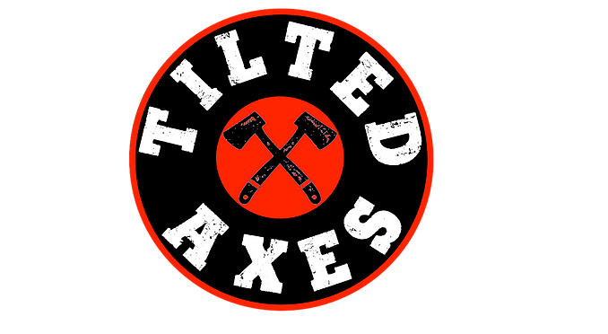
When: Saturday, November 27th
Where: Tilted Axes (18 Hagerty Blvd West Chester)
Time: 1pm-5pm

Participants: $45 each and must register prior to event online at www.tiltedaxeswc.com (click on Fundraisers & then Fundraisers-League signups to see the DEast Wrestling signup)

Ticket includes ax throwing, water/adult beverages, and food

Spectators: $15 Venmo @Jeff-Scott-212 (include name(s) & DEast Wrestling in the notes)

Ticket includes water/adult beverages and food

Available for purchase at event:
50/50 raffle tickets
Raffle baskets

May bring your own food/drinks

