SLPYHA Board Meeting Agenda
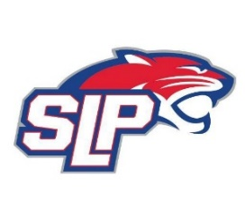
Date: 1/11/22
Fogerty
7:00pm

Attendees: Scott Lichter, Mike Mliner, Michelle Rice, Corey Piekarski, Jason Shipman, John Pitzl, Mike Fitzpatrick
Guests:

- President Report: Scott Lichter
- Call to order: 7:00pm
- Approve agenda
- Approve minutes from 11/22/2021 meeting, motion: Shipman move: Mliner
- Latest D10 updates
- D10 games
- COVID update
- Vice President Report: Michelle Rice/John Pitzl
  - Raffle drawing
  - Hockey Lab
- Treasurer Report/Gambling Report: Mike Mliner
  - November and December gambling report
  - Mliner motion to transfer $15,000 from gambling account to hockey account, approved by the board
  - Board also approved expenses for the month of December
- Secretary Report: Corey Piekarski
- Traveling Director Report: Jason Shipman/Adam Kiedrowski
- Girls Traveling Director Report: Kevin Mitties
- Mite Director Report: Mike Fitzpatrick
- Coaching Director Report: Jeremy Flaten/Bob Roloff
  - Red lined coaches
- New/ongoing Business:
- Motion to dismiss: 8:45pm, motion: Lichter move: Fitzpatrick

