Getting Started
Step 1: www.gowingers.com
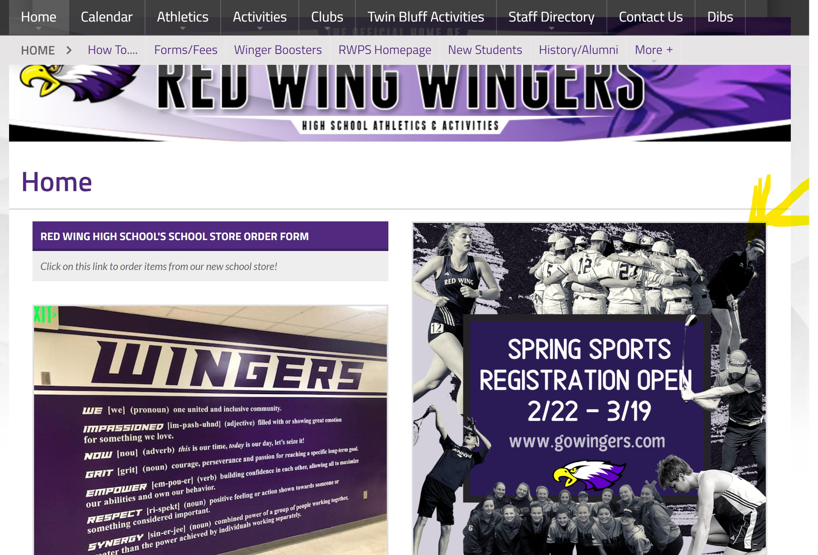
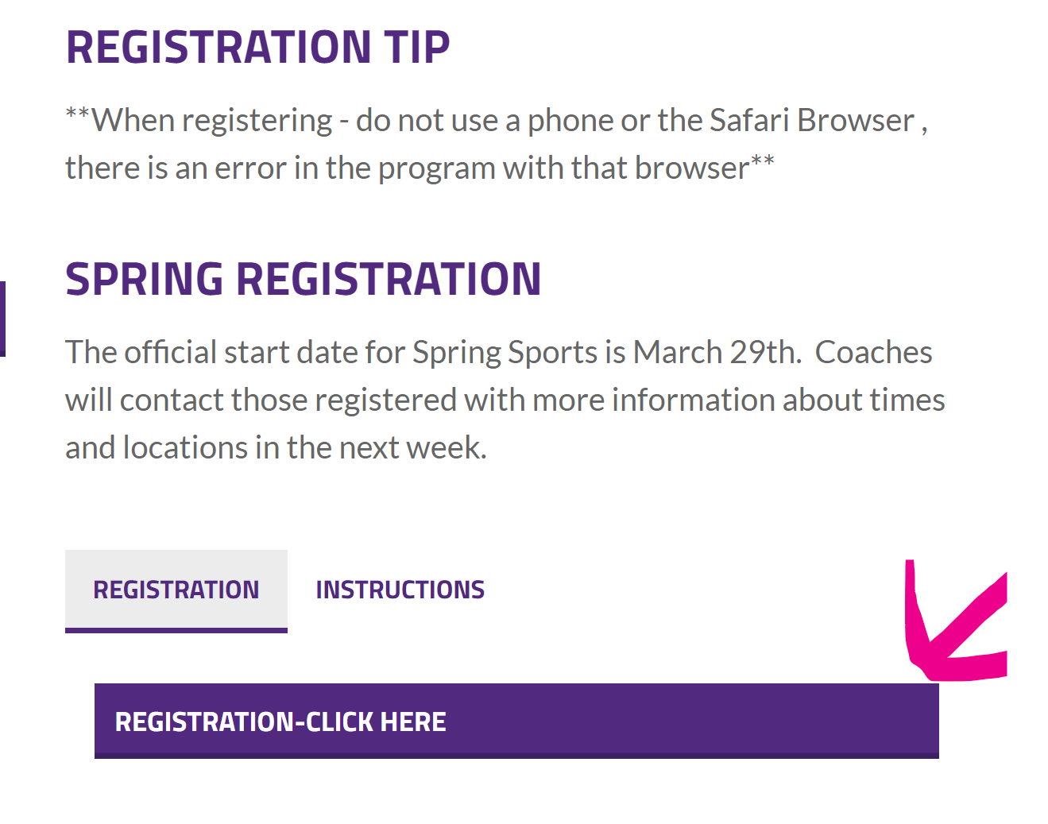
Step 2: Click the “Activity Registration” tab, you will be brought to the registration page:

Step 3: Click the “Athletic Team Registration”
New users (which all of you will be) please click: one of the following:
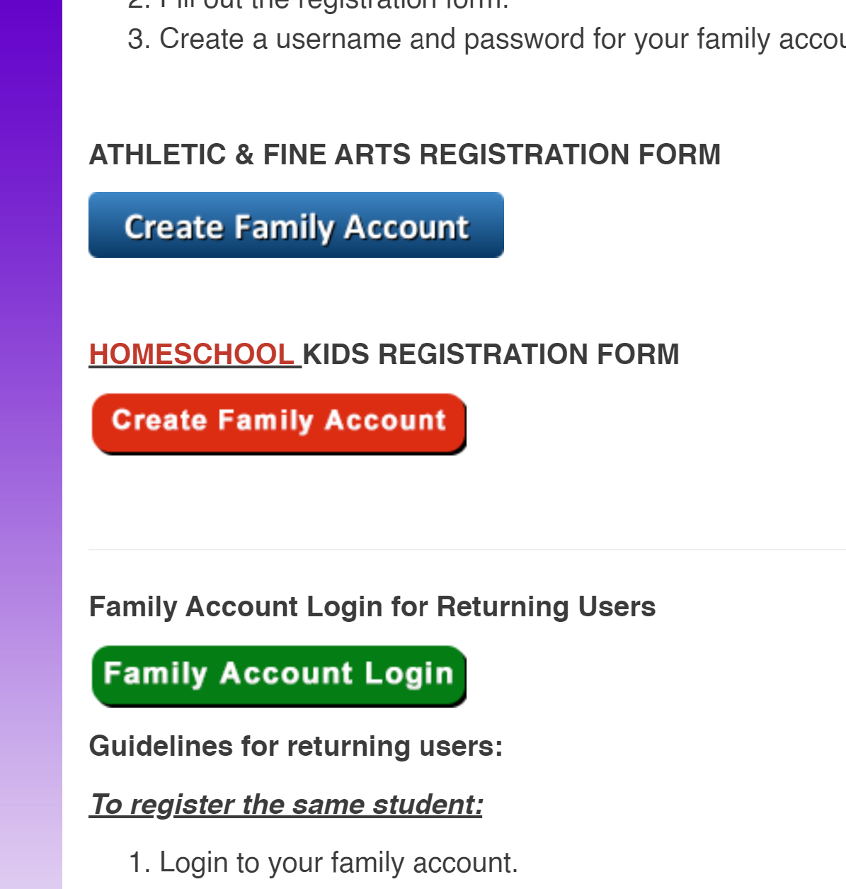
Read the choices carefully to select the one that best fits your needs for
THE CURRENT STUDENT YOU ARE REGISTERING

Step 4: Here you will need to enter your Student’s School ID and the Last Name (The students know them, and you can locate them on ParentVue, if you do not have access to ParentVue, please contact Beth Kelly in the H.S. Principals office)
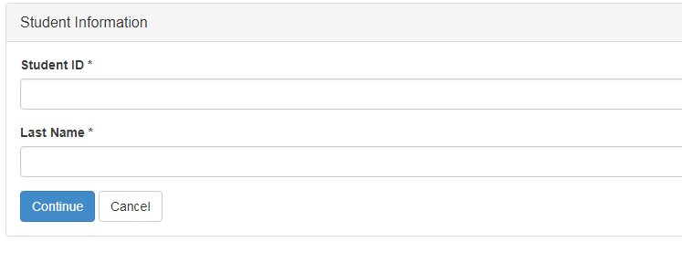
Step 5: This takes you to the Student Information section…some information will fill in for you, adjust as needed and fill in the spaces required/missing.
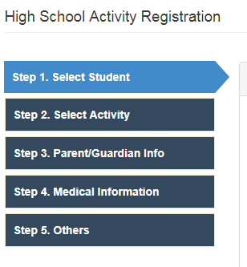
Step 6: Choose the activity being registered for
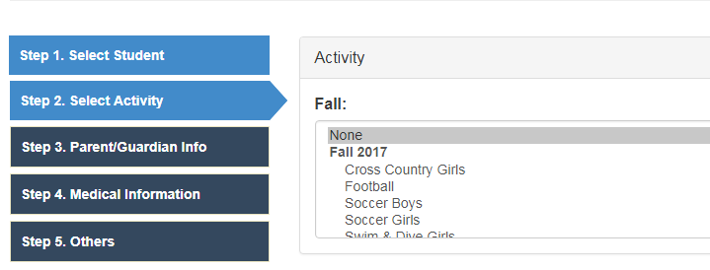
Step 7: Fill in the parent/guardian information
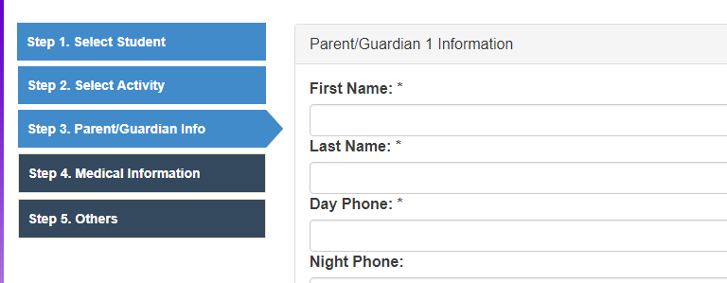
The next screen is medical information, it is not required, but in case of emergency, helpful.

Step 8: MSHSL ELIGIBILITY BROCHURE needs to be read, checked and electronically signed.
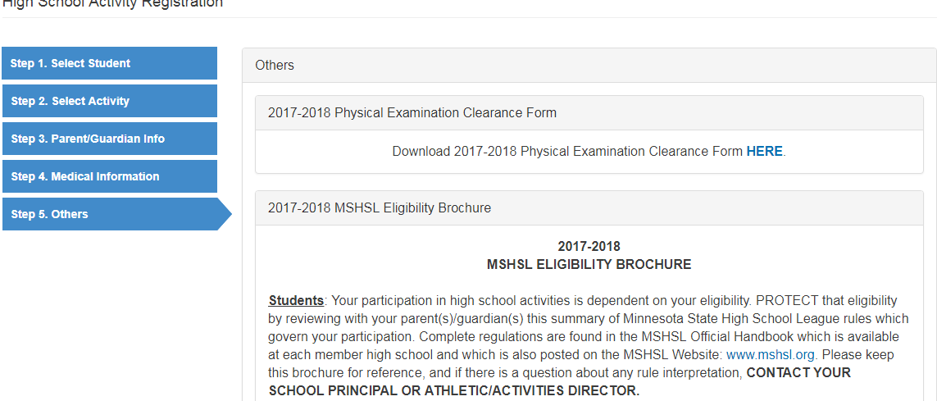

Step 9: Payment portion, you have 2 choices Please note, if you choose “continue to pay”, and change your mind, you cannot use the previous button to get back here. However, if you choose to “pay later”, you can still use a credit card when you sign back in to your account.
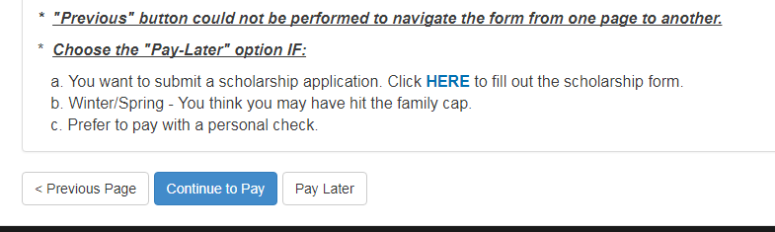

Step 10: Check out page this page will first have you set up the “family account” by choosing your own “user name” & “password”.
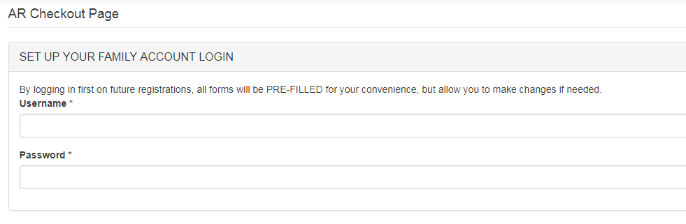
Step 11: Once done with that, scroll to the bottom and hit “submit” after you answer the math question
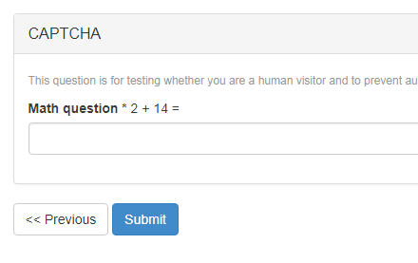
After hitting Submit, you should get a confirmation.

Returning Users: At www.gowingers.com you can sign in and get right into your account.

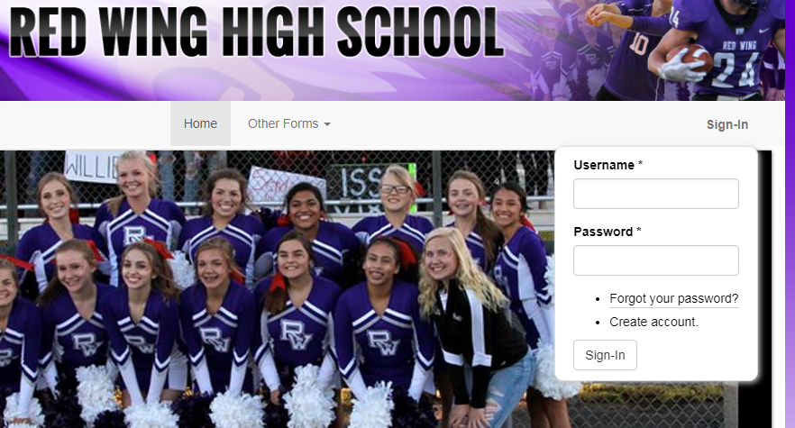
From there…you can also register a new student/another family member if need be, or register your student for another activity.

