Sinton Little League Sponsors 2020
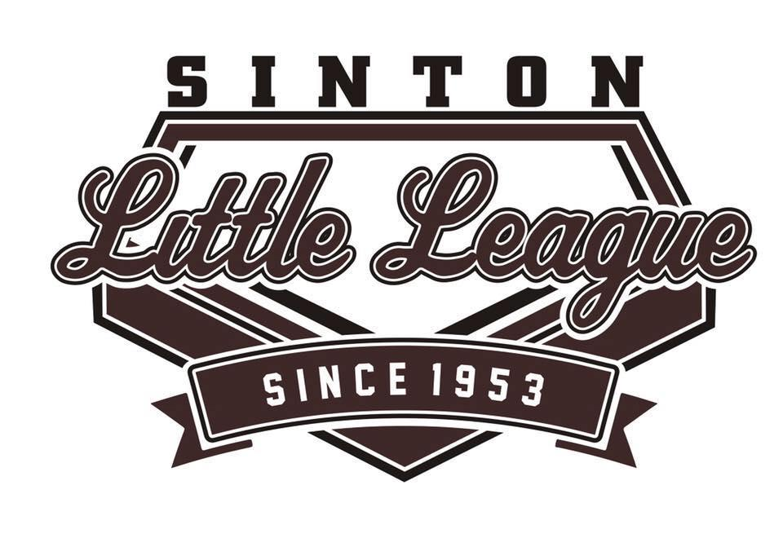
A new year is among us and with that comes change. Below are the tier levels for sponsorships. Sinton Little League hopes to promote your business, as well as give recognition this year and the years to follow. Any and all sponsorships and donations are greatly appreciated.

SPONSORSHIPS OF 250.00 WILL GET THE BUSINESS NAME ON A BANNER
SPONSORSHIPS OF 500.00 WILL GET THE BUSINESS NAME ON A BANNER and PLAQUE
SPONSORSHIPS OF 750.00 AND HIGHER WILL GET THE BUSINESS NAME ON A BANNER, A PLAQUE, AND AN ENGRAVED BAT.
IF YOU RECEIVE A SPONSORSHIP OF 500.00 OR MORE YOU WILL RECEIVE ONE FREE REGISTRATION. IF YOU HAVE ALREADY REGISTERED, YOU WILL BE REIMBURSED ANY REGISTRATION FEES PAID. ONE CHILD PER SPONSORSHIP.
It is time once again for Sinton Little League to begin its operating season and with that comes the need for financial support from our local community. SLL serves the Sinton Independent School District boundaries and is a chartered member of Little League, Inc. Every year team sponsorship funds are used to offset operating costs such as charter fee, insurance, uniforms, and equipment and field supplies. Your generous team sponsorship will assist with the funding of the 2019 Little League Season, in which we expect to register over 300 children.
If you have any questions you may contact the League President Matthew Villarreal at 361- 815-5484 or the League Treasurer Rebecca Rodriguez at 361-290-2451. Thank you for your consideration and support.
Childs Name: _________________________________Division: _______________________
Sponsor Information
COMPANY NAME:___________________________CONTACT PERSON:____________________________
ADDRESS: ________________________________________PHONE #:______________________________

Sinton Little League is a 501(c)(3) Non-Profit Charitable Organization.
EIN is 74-2697159 Please make checks payable to Sinton Little League.

