Activity Scheduler Mobile Application
New Feature Guide
Public View New User Interface Design
Version 2.0.0 (iOS)
09/14/2021

The Activity Scheduler Mobile Application Public View now has a new User Interface Design that ensures Public Users quick and straightforward access to different functions of the application.
Download and install the latest version of the application on your mobile device. Once installed, set the preferences (State, Conference, and School) and navigate your way to the Public View.
Installation and Setup:
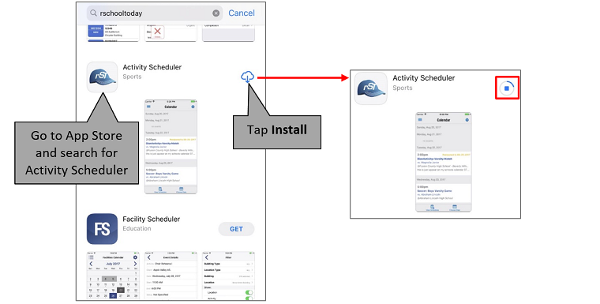
The background images change every time a User enters the App.
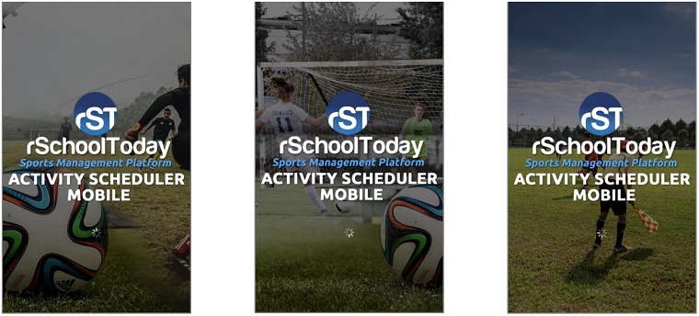
Select the State, Conference, and School.
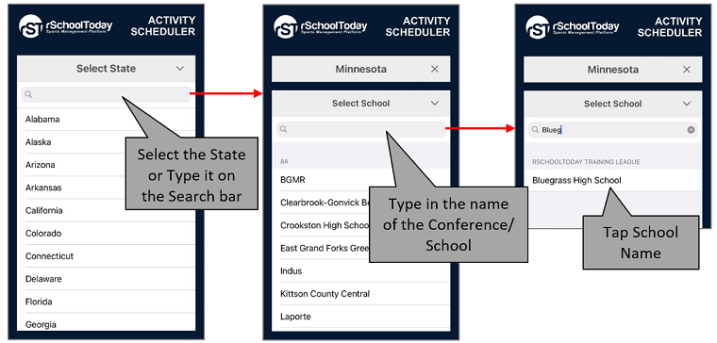
Public View Main Menu:
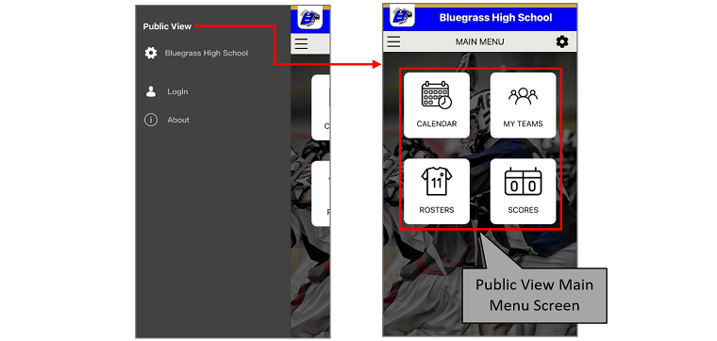
Administrators and Coaches Login:
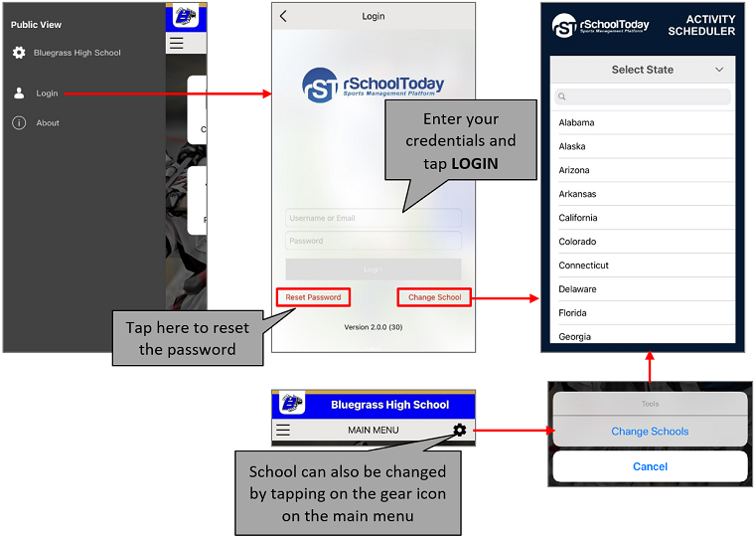
To view Setup History:
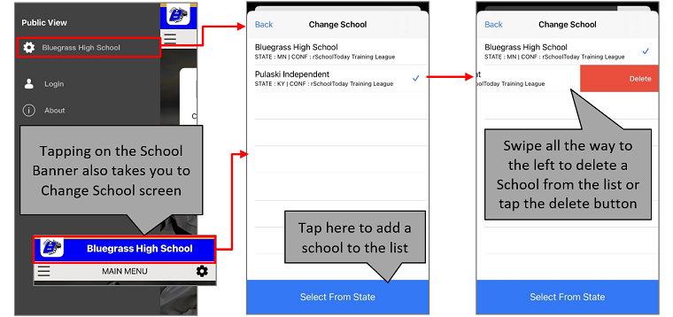
Tap on the Calendar Icon to view the schedules.
View Schedules – By Date:
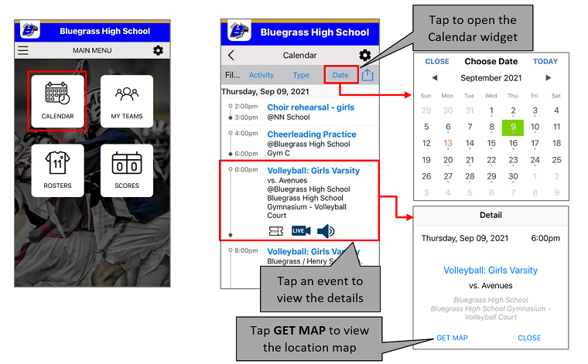
View Schedules – By Activity:
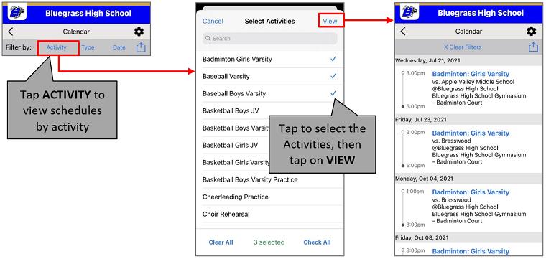
View Schedules – By Type (Categories):
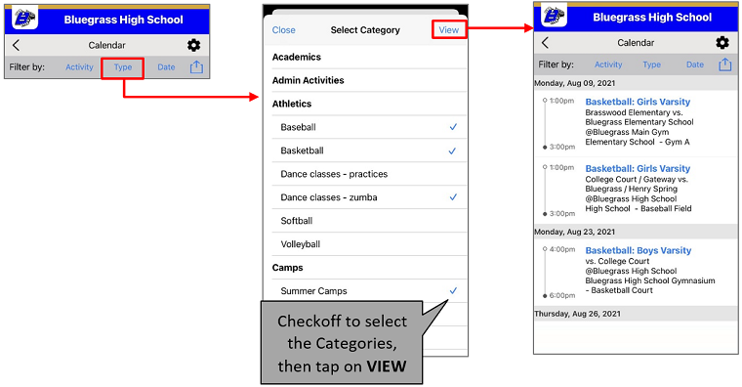
In View Schedules by Activity, users can save the schedules of activities that they have searched.
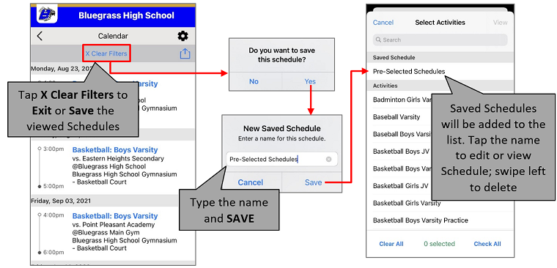
Users can also export schedules to their Calendar.
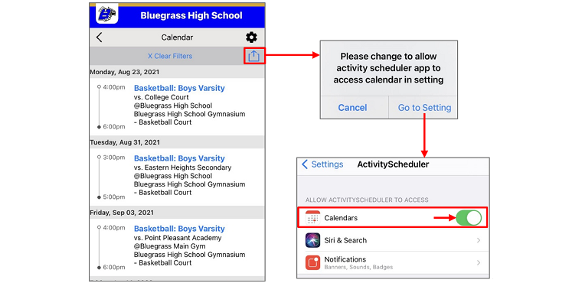
Viewing Scores – Tap on the Scores Icon to view the scores. You can also share them on your social media accounts (Facebook and Twitter).
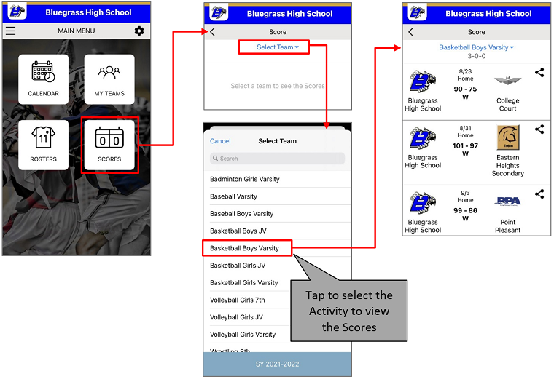
To share Scores on social media (Facebook and Twitter)
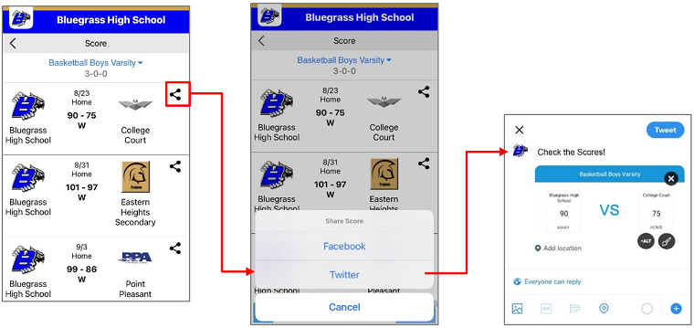
Viewing Rosters – Tap on the Rosters Icon to view the rosters.
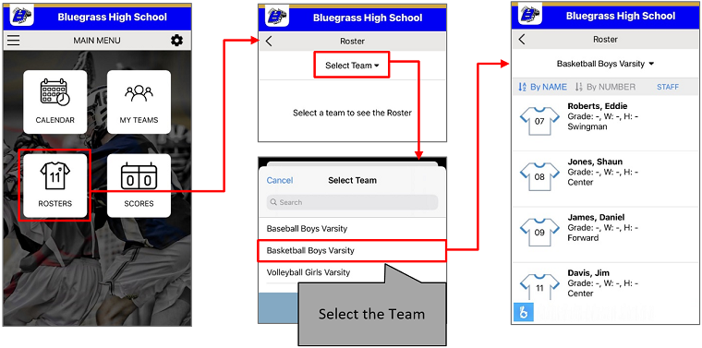
Students in the Roster can be viewed according to their names or jersey numbers.
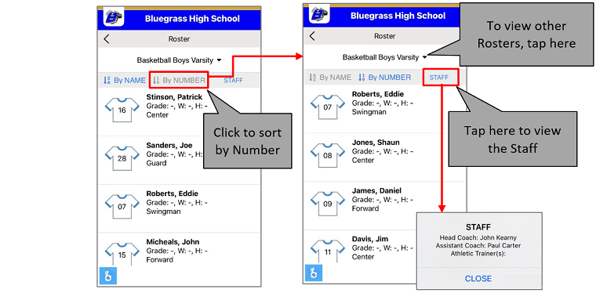
Managing Teams – Athletic Directors and Coaches can view and manage teams by tapping on My Teams Icon. Default Teams can be selected to display events.
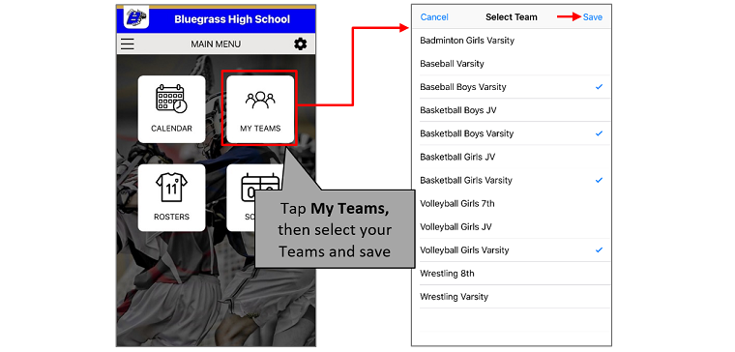
Once the selected Teams are saved, the application displays all the events by default.
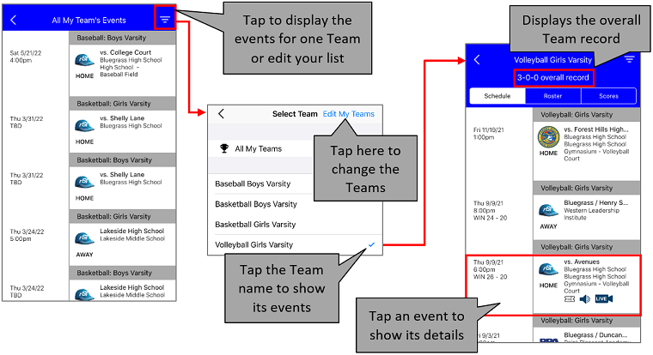
Here are the details of the selected event:
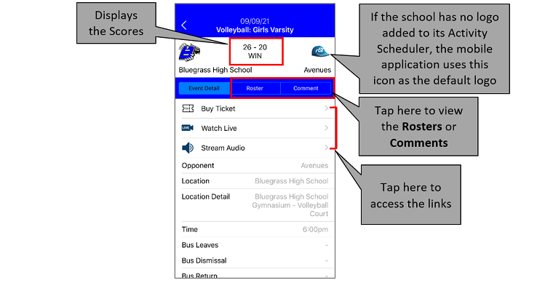
To view the Rosters of the selected Team, go back to the events screen and tap Roster:
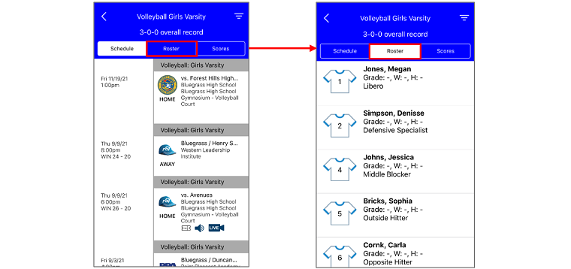
And, tap Scores to view its Scores:
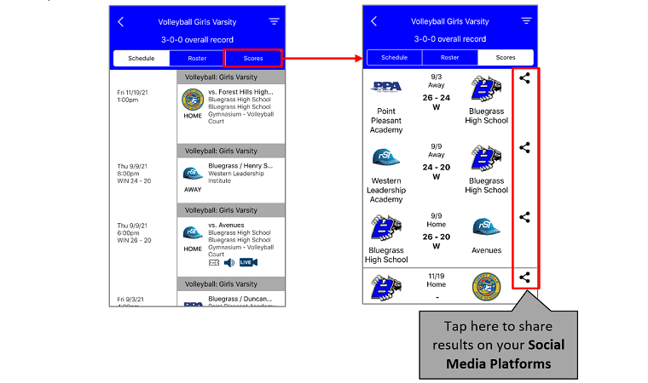
Note: The Rosters and Scores are only displayed when they are published on the Administrative side.
Privacy Policy:
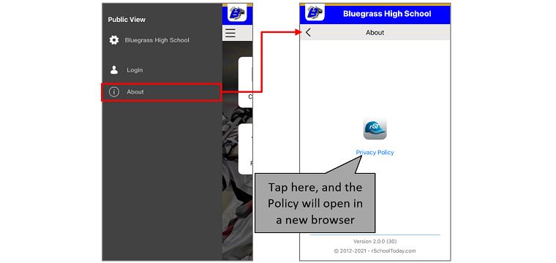
The DHS icon appears on the Main Menu Screen when a School is subscribed to the Daily Health Screening App.
