-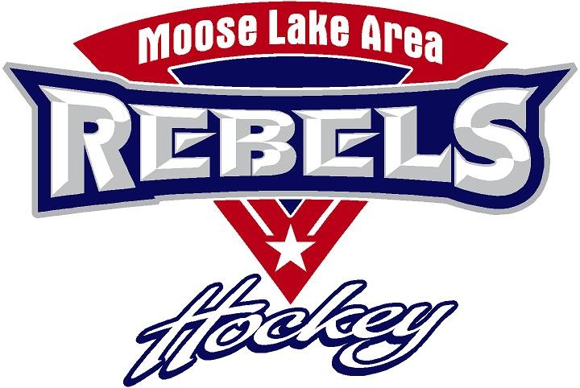 Moose Lake Area Hockey Association
Board Meeting Agenda Wednesday, January 22, 2019 7pm @ Rink
- Call to order and agenda review
- Review minutes from previous meeting, Maraya action item
- Gaming report, Jessica action item
  - Monthly reports and approval
Old Business
- Facility update - Pete/Timmy
  - Small Locker Rooms update
New Business
- Financials, AP - Julie
- Spring Meeting/Banquet - Abby
- Clock/Box Trainings - Kati
- Bantam District and PW Regional Tournaments – Chrissy /Heidi
- Open Positions – Nominations Open – Chrissy
  - President (Exec Board), At-Large (Exec Board), Tournament Coordinator & Registration
- Directors reports:
  - PD – Seth
  - Tournaments - Heidi
    - 2020-2021 fees and cancelation policy
    - MN Hockey Rule – Removing Paid Teams
  - Recruitment & Retention - Amber
  - Scheduling -Dale
  - Registration - Abby
  - Rinks and Grounds – Timmy/ Pete
  - Concessions - Holly
    - How do we improve coverage?
Closed Meeting
- The Executive Board, Board of Directors, and Player Development Committee will meet following the Open Board Meeting.

