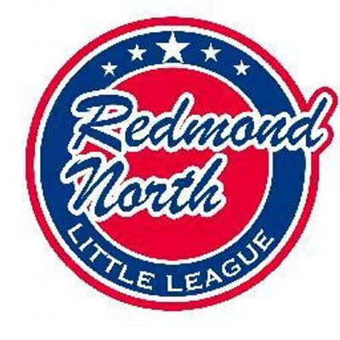

December 17th 2019 Meeting Minutes

In attendance:

Kara Kostoff
Sean Cronkite
Alec Weintraub
Jamey McMahan
Kristal McMahan
Kathy Duncan
Jeff Cobb
Stacey Hanson
John Mason
Matt Winkler
Meghan Dosch

Alec opened the meeting and handed out baseball flyers for board members to pass out. Recruiting new and returning players remains a priority.

Evaluation Day

Jamey confirmed that all is going well with evaluation day planning. SBA is booked and there are a number of high school kids who are looking for volunteer hours to help out during the day. The player agent will have the data from last years evaluations and the manager feedback is available from last year too. Jamey to follow up. New kids who are unable to show for evaluation day will need a separate opportunity to show their skills. Batting station needs to be speeded up – it was suggested that having to adjust the batting machines from tall to short kids took up the most time.

Managers

A number of interested managers have been identified:

Majors : Sean Cronkite, Mike Kafchinsky, Mike Komola, Robin Wood and Kellys Forsmann.

Coast: Matt McNaughton, Mike Sessions, Brock Huard, Tristan Butler and Mike Russell.

AAA: Jesse Collins
Intermediates: Jason Schafer

Juniors: Mike Condon

In relation to softball further discussions need to be had in relation to whether to combine with Red West or remain as a Red North teams. It is understood that we all want what is best to keep the kids having fun and playing ball.

A question arose as to whether a Redmond West 14 year old would be able to join the Redmond North Intermediates team if they wished. They would need to register through Redmond West first.

Registration

Registration numbers are at 131 so far. Alec to send email to have a final push to improve numbers. Matt to put another ad on Facebook. Flyers, Instagram / facebook postings, contact by last years managers etc.

Umpire in Chief

Umpire training is booked together with Redmond West for March 5th, 6th and 7th. New umpire training will be separate from returning umpires. There will be a coaches rules training with one of the Kirkland organizations, which will be open to anyone who wants to attend.
Umpires Northwest contract is not yet completed. Jeff also requested the umpire mailing list from last year.
The Mission document is 90% completed. It is not believed to need D9 approval, we just need to have it. Softball, Intermediates, Juniors and Seniors need to be included in the document.
Update needed on Interlock rules. All leagues seem to be happy to proceed with the Redmond North Little League rules. Main issues are minimum play rules.
Umpire gear needs to be labeled as belonging to RNLL. Chest protectors needed. John Mason to send catalogue details to Jeff and will then order what is needed.

Fundraising

Kristal to meet up with Meghan to discuss complete handover. Meghan confirmed that Dick’s Sporting goods will go ahead with the scoreboard advertising and has already received the cheque for $2,500. Dicks vouchers are normally sent to Meghan in January and she will arrange for them to get to Stacey for scholarship kids.
The Joint Chiropractor requested having a spot at Evaluation Day. It was deemed to be too small a space for any vendors to be included. It may be possible for them to be at Redmond Ridge Fields during Opening Day or Picture Day perhaps.

Batting Facility

Pre-Construction meeting is to be held tomorrow, Wednesday 18th at 1pm. Ground breaking to occur in the next 1-2 weeks with a completion date in May. Bids have been received for netting, mounds and pitching machines. Contractor is ready to go. Sean Cronkite, John Mason and Matt Winkler are the building committee.

Web Master

Changes are all done for registration. Events need to be inputted into the calendar. Ideas for facebook page – perhaps a ground-breaking ceremony?

Equipment

Clothes rack has been installed in the container. AD Star do not sell the All Weather baseballs but the feedback on the Practice balls was not positive. All Weather balls to be purchased from elsewhere.

Schedule

Meghan produced a season schedule – see details below. Matt to input details onto website:

January 18th Evaluation Day at SBA

February 22-23rd Dicks Shopping Days

March 1st Practices Begin
March 14th Boot Camp IB
March 12th &19th Pitching Training
March 9th & 16th Catching Training at SBA
March 19-27th Pre Season games RWLL
March 28th Upper Division Opening Day

April 6-10th LWSD Spring Break
April 13th IB Opening Day
May 2nd Picture Day??
May 3rd Mariners Day
May 20th Final Day of Regular Season
May 27th RCT Begins

June 3rd RCT Championship game
June 9th – 11th JR Tournament
June 13th IB Jamboree
June 20th 10s All Star Tournament
June 20th Juniors All Stars @ Redmond Ridge
June 27th 11s All Star Tournament

July 4th 12s All Star Tournament
July 13-16th 9am – 12pm Baseball Positive Camp

Next Meeting

Next meeting will be Tuesday 21st January 2020, at Ixtapa Redmond Ridge.

