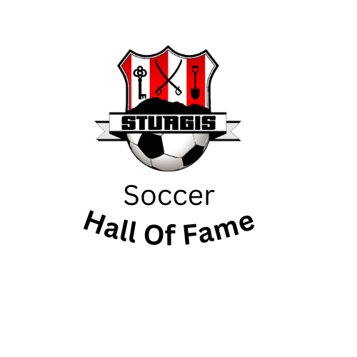
Sturgis Soccer Association Hall of Fame
The Sturgis Soccer Association Hall of Fame was created to recognize athletes, volunteers, and contributors for their dedication, accomplishments, and contributions to the Sturgis Soccer Association. The following criteria are set forth as a guideline for acceptance to the SSAHoF but are in no way meant to represent prerequisites that must be met for a candidate to be considered. A candidate may have merits that are not listed herein yet bear significant weight towards advancing soccer in our community.
- Eligibility
  - Dedication
A candidate must have been involved with soccer in Sturgis for a minimum of five years. Candidates accumulate years of involvement for each role they served. For example, a player who was also a referee during the same year of involvement would count that as two years. Candidates that go on to the collegiate or professional levels get to count those years as if they were still involved at the local level.
  - Character
The SSAHoF does have a character requirement. Each candidate should have represented Sturgis Soccer in a positive light at all times. Areas to consider would be whether the candidate was a leader to their teammates and worked to elevate his level of play and that of his teammates; did the candidate display the characteristics of sportsmanship that we feel distinguishes Sturgis; did the candidate demonstrate the work ethic worthy of consideration to such an honor.
  - Accomplishments
A distinguished period with Sturgis soccer is of primary importance. Awards, records, and statistics are clear indicators in this area as well as those efforts that drove the sport forward off the field.
- Nomination and Selection Process
  - Source of Nomination
Nominations are accepted from the Sturgis coaching staff (past and present), SSA HoF members, Sturgis Soccer and Sturgis Brown High School alumni, and other members of the Sturgis community that provide a complete and detailed nomination card. Finalists from the previous years that were not selected can be automatically considered, at the committee’s discretion.

  - Structure of Nomination
Nominators are expected to respond in writing to the committee with not only the candidate’s names but also the specifics facts and or statistics that they believe distinguish the candidate, taking into consideration the eligibility requirements above. It is important that the nominator specifically list any reason the candidate is to be considered and not rely on the committee members to do so. Simply listing the name of a nominee will not be enough.
  - Selection of HoF Inductees
Once the nominations have been submitted to the selection committee, the committee itself will undertake the responsibility of selecting the induction class. The following guidelines are to be used as a guide (and not a mandate) in the final selection process.
    - Selection of Finalists
Once the candidates are examined by the selection committee, a vote will occur. Each committee member will have a total of five votes and may cast all their votes on one candidate or spread their votes among several candidates. The selection committee will tabulate the total votes and select up to five finalists based on the total number of votes received.
    - Selection of Inductee Class
Once the finalists are chosen, the committee will then make its selection of up to two inductees for a given year. Each member of the selection committee will rank each candidate in order, assigning a value of 1-5 (5 for the most deserving nominee). The committee will closely examine the candidate’s qualities and background against the criterion set above. If the committee feels the need to take additional time to choose the inductees, the committee can do so. This close scrutiny of the candidate’s qualities is the reasoning behind requiring detailed information from the nominator.
    - Notifying the Induction Class
Once the SSAHoF Induction Class has been selected, both the new inductee and the nominator will be notified. Details regarding induction at the SSAHoF Banquet will be quickly disseminated in order for inductees to make the appropriate arrangements.
- Committee Makeup
Ideally the Hall of Fame Selection Committee will be a wide cross section of individuals. As the years progress, it is important that all eras of Sturgis soccer are duly represented. The selection committee will be regenerated from year to year and chosen based on requests and selection of the Sturgis Soccer Association Board of Directors. Participation in the selection committee will not prohibit a committee member from nominating a prospective inductee.
  - Player
There shall be a player, past or present, on the selection committee.
  - Coach
Since the coaching staff is such a vital link to the history of Sturgis soccer, it is of crucial importance that members of the Sturgis soccer coaching staff are part of the committee. There shall be a coach, past or present, on the selection committee. Participation in the selection committee will not prohibit a committee member from nominating a prospective inductee.
  - Referee
There shall be a referee, past or present, on the selection committee.
  - SSA Board Member
There shall be an SSA board member on the selection committee. In addition to their requirements as a selection committee member, this individual will also serve as a liaison between the Hall of Fame and the Sturgis Soccer Association Board.
  - Ad Hoc Member/Hall of Fame Member
The inaugural class selection committee will have an ad hoc member selected by the SSA Board of Directors. All subsequent years, this chair in the committee will be occupied by a former inductee to the SSA HoF as chosen by the SSA board.

