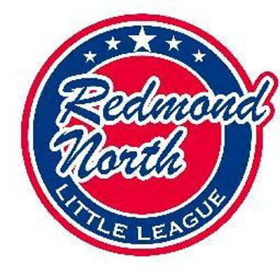

January 21st Meeting Minutes

In attendance:

Jamey McMahan
Tiffany Gore
Alec Weintraub
Jeff Cobb
Kara Kostoff
Sean Cronkite
Kathy Duncan
Kristal McMahan
Stacey Hanson
Jessica Martin
Matt Winkler
John Mason
Ellen Reed
Rachel Cady

Evaluation Day

Alec opened the meeting by thanking Jamey and Kristal together with all the volunteer helpers for a successful Evaluation day. Everything flowed very well, with the only comment being that we might consider a smaller amount of time for the 8 year olds as fewer showed up than expected.

The Majors draft is to take place Thursday 23rd, with Coast to be arranged for a day next week. There is one request for a 12 year old to play down to Coast. Alec to submit request to D9. The numbers indicate that a couple of last years 10s All Stars may end up playing Coast. There will be 4 Majors teams, 4 Coast teams and 4 AAA teams.

Dave Biddle has agreed to be the AAA VP. Sean Cronkite and Jeff Cobb to follow up with Dave to offer help.

Registration

We received a few more softball registrations in the past few days. IB registration to stay open, probably until 1st March. Can still accept 8 and 9 year olds to play AA.

Softball

Rachel Cady was introduced to the board. Rachel, together with Kara Kostoff are leading the softball program for Redmond North Little League, working with Redmond West Little League. There was a desire among families to stay combined at all levels despite higher registration numbers.

There will be a new logo for Redmond Softball to be more inclusive of both Redmond North and Redmond West girls.

Fees to be discussed with Redmond West now that we have more input into running the Softball program. Uniforms etc. are ordered through Redmond West.

Umpire in Chief

Local Rules have been signed off by D9. There was some retouching of the rules but no relevant changes. Matt Winkler to get the new Local Rules up on the website. Jeff to have a meeting on Thursday to sort through the Interlock Rules with the other leagues, also rules for the tournaments etc.
All umpire equipment and swag has been organized. There are a few things still to be ordered. Jeff to follow up with Jessica for payment.
Umpire training is scheduled and needs to be put on the website. This is being held in conjunction with Redmond West and Kirkland National. Jeff to get contact details for Junior Umpires from John Kim in order to encourage them to take this training.
UNW – same rates as last year. However there may be fewer games as we have fewer teams. If this this the case a 10% decrease was suggested.

Training

Mariners Training is coming up. There is one session to be held on Saturday at Safeco field and other one to be held on a Saturday in March, locally with a number of D9 leagues. $200 has also been committed to Big Al Online Training.
Baseball Positive Pitching Clinics are to be held on March 12th and March 19th.
Baseball Positive Bootcamp is to be held on March 14th
SBA Catchers Clinic is being held on 9th March and 16th March.
SBA Coaches Clinics IB Managers on 25th March
AAA & up on 18th March
Tiffany also researched Bill Krueger training clinics, however these were very expensive.

Fundraising.

Kristal thanked Jeff Cobb for his help with securing the banners at Redmond Ridge. Jeff suggested some zip ties be kept at the container for easy fixing.

Web Master

Facebook advertising is being continued. Matt would like to do another one specifically aimed at T-ball / IB ages.
Aliases are to be updated. Some events need to be taken down. Any observations of errors on the site are requested to be emailed directly to Matt, who will take care of them.

Instructional Baseball

Registration to remain open for IB until March 1st. Alec attended the free baseball at EL1 day last Friday. The event was well run and something we should consider for next year.
Alec has identified a group of interested parents to help run the IB coordinator role. To meet with them next week.

Batting Facility

Ground has been broken at Redmond Ridge. Insurance is now to be procured for the batting cages. The donation of $75k has been received although check needs to be reissued as it is made out to Little League, not Redmond North Little League.
A Batting Facility Co-ordinator is needed to deal with rentals etc. Website will need to be set up.

Player Agent

Working on data for the draft. To discuss a few requests to play down with Alec as 12 year olds need to play Majors unless approved by the District.

D9 are working on a Home Run Derby. More details to follow.

Next Meeting

Next meeting will be Tuesday 18thFebruary 2020, at Ixtapa Redmond Ridge.

