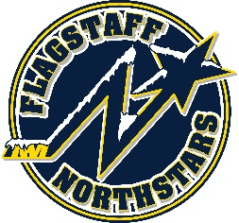
Flagstaff Youth Hockey Association
BOARD OF DIRECTOR’S MONTHLY MEETING AGENDA
September 15, 2021

Topic: FYHA General Board Meeting
Time: September 15, 2021 @ 6:00PM
Location: 215 E Birch Ave

GENERAL BOARD MEETING
Topic: FYHA General Board Meeting
Time: 6:00pm

Approval of Minutes:
Reports
- President’s Report- Travis Joralmon: Seeding Tournament Update
- AAHA Hockey Director- Travis Joralmon: Team Decisioning Set; Mite Jamborees
- ADM Coordinator: Kris Walsh:
- Coaching Coordinator- Travis Johanson:
- Equipment Manager- Greg McLaughlin
- Fundraising Coordinator-Kyle Palmer:
- Ice Scheduler-Brad Mihalik: referees, ice-time timelines
- COVID Updates and Protocols- Brad Mihalik:
- Registrar-Judy Smith:
- Treasurer-Lauryn Sandoval:
- Webmaster-Courtney Matthews :

UPCOMING EVENTS:
- Little Howlers 7/31-9/25
- Club to start 9/27/2021

OLD BUSINESS:
- Dryland for 12U/14U @ FIIT Nation—invoice

NEW BUSINESS:
- Coaches sign up for Sunday stick time/goalie skills
- Travel Team Photos
- Team store through Hockey Monkey
- Old Jerseys
- Can/Am team gifts
- Refs
- Splash Guards
- 6u coaching possibly combination with 8u club.
Executive Session: (?)
- 14U Players requesting release from team

