SARTELL SAUK RAPIDS LACROSSE ASSOCIATION
Board of Directors Meeting
Tuesday, January 16th, 2023
6:00 PM
Sartell House of Pizza

Meeting Minutes
Approved

Call to order: 6:04 pm - Jason Bambenek

Roll Call:

Position | Name | Present
President | Jason Bambenek | x
Vice President | Danielle Granroth | x
Treasurer | Michelle Johnson | x
Secretary | Joan Hooper
Boys Coordinator
Girls Coordinator | Beth Atkinson | x
Coach/Player Development Coordinator | Brandon Urke nominated 12/18 | x
Registration Manager | Ryan Newman | x
Schedule Coordinator
Volunteer Coordinator | Jessica Rothstein
Equipment Manager | Lewis Solarz
Fundraising Sponsorship Coordinator | Beth Atkinson | x
Media Coordinator | Erika Pool
Apparel Coordinator | Heidi Dankers
Picture Coordinator | Jackie Reese | x
Gambling/Raffle Coordinator | Mollie Newman/Jessica Rothstein | x(JR)
Facilities Coordinator | Mark Giese
Outreach, Recruitment and Retention Manager
Game Day Coordinator | Mark Giese
Guests
Review Agenda/Additions to Agenda:

Review Minutes: Approved; Motion: Jason B., Second: Michelle J.
- Corrected spelling of Erika Pool’s first name. It is a “k” not a “c”

Treasurer’s Report: Approved; Motion: Beth A. , Second: Jason B.
- See report below
- Taxes-Michelle will file

- Follow-up: Michelle to file taxes

Regular Business:

President Report - (Jason/Danielle):
Jason:
- Volunteers needed
  - Coordinator positions and recruitment needed. Reese provided a recommendation, Bambenek to follow up/reach out
  - Vote - Brandon Urke voted in- all in favor. Ryan Newman to set up sports engine access for Brandon
- Tax status
- **All board members must register as volunteers and complete safe sport training. If already completed with hockey provided certificate for verification, no need to redo training. Add Safesport link to the registration of volunteers (RN)

  - Follow-up: Jason will reach out to individual recommended by Jackie Reese regarding outreach, recruitment, and retention manager

  - Follow-up: Ryan N. to set up Brandon Urke with access to Sports Engine

  - Follow-up: ALL BOARD MEMBERS: register as volunteers and complete safe sport training

  - Follow-up: Ryan N. to add Safesport link to the registration of volunteers

Danielle:
- Lax free event – coupons
  - Registration for event - free. Recommended but not required? Coupon Code for those attending to use on registration for regular season 10% - Ryan to set up registration and activate coupon code option.
- Community center reserved for Jan11, 10-12:00 PM
- Michelle provided check to Danielle to make payment. No insurance required. Set up and tear down 30 minutes before and after.
- Next steps:
  - Joan - email to St. Bens girls’ coach to invite him and player volunteers. If involved push for girls only event.
  - Ryan Newman - volunteered to be point person for day of event
  - Lewis - please gather equipment for event. Order foam vs. regular balls (Community center wall is glass - foam preferred)

- Promotion of event:
    - edit flyer and make available at arenas, schools, community centers.
    - Newsleader?
    - Create Facebook event and boost with paid ads? (Beth/Jason expressed some knowledge on the subject)
    - email list via sports engine
- Jason - mentioned list of area lacrosse contacts for email promotion
- Event staffing: who is available??? Ryan, Danielle, Joan. Potential with St. Bens players. Michelle to reach out via high school girls’ team for volunteers.
- Emphasis on “Now forming - all girls lacrosse teams.”

- Follow-up: Joan - email to St. Bens girls’ coach to invite him and player volunteers. If involved push for girls only event.
- Follow-up: Lewis S. - please gather equipment for event. Order foam vs. regular balls (Community center wall is glass - foam preferred)
- Follow-up: Ryan N. to set up registration and activate coupon code option.
- Follow-up: Danielle to make payment for gym reservation at Sartell Community Center
- Follow-up: Michelle to reach out to high school girls team for volunteers

Boys Coordinator Report - (Open Position)
- Jason:
  - Refunds:
    - Will refund Spring but not summer
    - Automatic if season ending injury
    - Drop-outs from summer program if originally registered for Spring and Summer at same time-ok but reimbursed amount will be adjusted to cover the full Spring payment
    - Case-by-case basis

Girls Coordinator Report - (Beth Atkinson-present)
- Jing-SSR HS Girls

Coach and Player Development Report - (Brandon Urke-present)
- Brandon Urke voted into this position
- Coaching Staff 2023 Certification/Spreadsheet
- Coach Certification/Training/Process
- Player skill expectations per age level
- Off-season contest for players-sharing links with parents/players of skills to practice

Registration Manager - (Ryan Newman)
- Email sent to all members in the updated list on Sports Engine
- Blast to other local cities
- Flyers-other sports to market to
- 2024 Registration Planning:
  - Current registrations 8
  - Register teams’ spring/summer and state boys and girls
- Assistance/refunds to registration manager-case by case-if injury refund will be given

  - Follow-up: Ryan N to create tab or link for financial assistance/sponsorship that links to the association email. Refer to hockey webpage for verbiage ideas-will be a case by case decision.

Schedule Coordinator - (open position)
- Once available, schedules need to be posted online-of this position is not filled the Team Manager will be responsible for adding this information for their team

Volunteer Coordinator - (Jessica Rothstein-present)
- Dibs information emailed

Equipment Manager - (Lewis Solarz-not present)
- Girls equipment-inventory and certified, etc.?
- Please order balls-include foam style balls for Try LAX event

  - Follow-up: Lewis S. to order regular and foam style balls *will need foam balls by 2/11

Fundraising Sponsorship Coordinator - (Beth Atkinson-present)

  - Follow-up: Beth to do outreach to 2024 sponsors-update website

Media Coordinator - (Erika Pool)
- Needs access to Facebook and Sports Engine
- Homegrown Lacrosse Clinics March 9 & 15th Grade 3-12
- Blast that Girls LAX now offered
- Try LAX coming up/Girls only also? Local cities to repost
- Website
  - Jason: Free reign, maintain functionality and connect with person in charge of that area (i.e. registration, sponsors, etc.)
  - Heidi would like uniform ordering information on home page
  - Registration, etc.,
  - Take off 2020-fix titles

  - Follow-up: Jason to adjust spelling of Erika’s name on agenda’s going forward

  - Follow-up: Ryan N to send Erika access information for Facebook and Sports Engine

Apparel Coordinator - (Heidi Dankers-not present)
- Heidi would like uniform ordering information to be added to the home page

Picture Coordinator - (Jackie Reese-present)

  - Follow-up: Ryan N to provide spreadsheet and Sports Engine Access

Gambling/Raffle Coordinator - (Mollie Newman/Jessica Rothstein)
- Meeting set-ticket ex and prizes
- Coordination with high school raffle tickets decided. 45 sets of tickets, 35/set. Take is 60/40 SHS/SSRLAX
- Contact Jess Rademacher

  - Follow-up: Jason to send email to Jess Rademacher due to lack of response so far

Facilities Coordinator - (Mark Giese-not present)

Outreach,Recruitement and Retention Manager - (open position)
- Coordinator positions and recruitment needed. Reese provided a recommendation, Bambenek to follow up/reach out

  - Follow-up: Jason will reach out to individual recommended by Jackie Reese regarding outreach, recruitment, and retention manager

Game Day Coordinator - (Mark Giese-not present)
Jason:
- 2024 field reservations
- Host day will be May 19th
- Waiting on SAC for indoor
- Facilities improvement opportunities-bathroom, signage, map, parking

New Business:
- Attached email was sent on 1/13/24 to board members to review and to be discussed during this meeting.
  - Website discussion:
    - Jason: okay to update banner and make all changes needed
  - Try Lacrosse for Free: February 11th from 10-12
    - See discussion above under President Report/Danielle
  - Schedule Coordination with neighboring associations
    - Jason: We will not be partnering with Rocori Youth Lacrosse, they are not part of GNLL
  - By Laws
    - Jason: Tabled-Set up meeting specific to bylaws. Do we also need to have a handbook drafted as well?
  - Updates to Board Positions Descriptions and Define *Voting positions (Website)

Old Business:
- By laws need to be updated

Open Floor:
Announcements:
Next Meeting agenda items:

- Submit additional agenda items 7 days prior to meeting via email to SartellSaukRapidsLax@gmail.com
- Next meeting: Tuesday, February 20th at 6 pm, Sartell House of Pizza

Adjournment: 7:20 pm – Motion: Jason
Minutes respectfully submitted by Danielle Granroth, Interim Vice President

Treasurer’s Report:
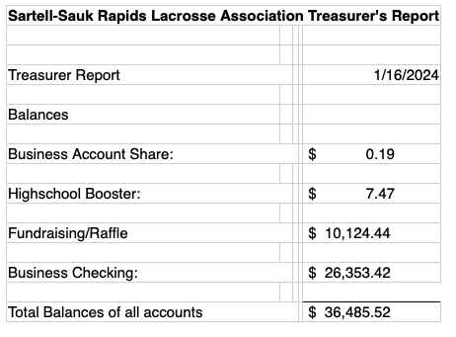

Email of discussion topics for 1/16/24 meeting:

Good morning,

Please take a moment or two to review the bullet points in this email BEFORE Tuesday's meeting if possible. Since there are new members to the board, myself included, there are questions that may need to be answered so that we can keep moving forward more efficiently. Speaking for myself, the more I understand - the more productive I will be!

Website:
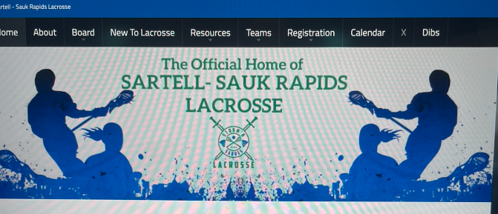
Joan and I have spent time cleaning up the website. It is still a work in progress as there are a couple of items that we needed clarification on. Please take a minute to peruse the updates ahead of the meeting Tuesday. Also, I have mocked up a replacement header for the page that has our logo. I have not made the change yet as I wanted to get a consensus. Here is a preview of what it would look like
Joan has also been in contact with Erika and we will work together to get her comfortable with handling some of the social and website content.

Try Lacrosse for Free: February 11, 10-12:00
I currently have a hold on the gym space at the Sartell Community Center for the proposed Try Lacrosse for free event. Biggest concern is staffing. Who is available that Sunday? Hockey conflicts? It is super bowl Sunday, but this should get us all home in time for pre-game.

I received an email from a neighboring organization recently and there are contacts on the email for Rocori, St. Cloud etc. - this may be a place to start, for inviting other communities.

Rental fee for this event is roughly $100. (If we have proof of our nonprofit (assuming we are a nonprofit) we can knock off the tax, but it was only around 7 dollars.)

If we could decide Tuesday night if this event is going to be possible. Michelle if I could get a check at that time for the community center as we will not meet again before the event happens.

Schedule Coordination with neighboring associations:
We have received an email from the ROCORI lacrosse association requesting that we collaborate on scheduling. I have included the email below. Mark would you be our go to on this?
Hi, I’m Jason from Rocori Youth Lacrosse.
Included in this thread are various coordinators from Sauk Rapids, Sartell, St Cloud, Hutch, and Rocori.
Last year it came to my attention, by way of home game scheduling difficulties, that it might be a good idea for our programs to at least somewhat coordinate when we plan to host. We host one weekend per season. Last year we had a hard time getting teams to come to our place because most, if not all, of us were hosting the same weekend. It ended up working out fine, but not without hassle. I was thinking it might benefit all of us to communicate a little bit about our host weekend plans.
Do you know when you plan to host? We don’t have a date ironed out yet.
Are you interested in trying to coordinate a bit?

By Laws:
Bylaws need to be updated and finalized to match SSRLAX. Joan has been making edits to the previous one that was adopted from St. Cloud Lacrosse. This is not my area of expertise as far as the language. For those of you with previous board member experience I am calling on you to help! Joan has a draft with proposed edits, and I will attach that to this email. She has used the current Bylaws for the association (the ones that still had St. Cloud Lacrosse Association that were sent out) and some she found online from other associations. The highlighted sections are numbers that were edited to fit our association.

I will bring along a printed copy or two so that we can make notes and then finalize edits and send them out for review.

DRAFT 2024 Sartell-Sauk Rapids Lacrosse Bylaws....

Updates to Board Positions Description and Define *Voting positions (Website):

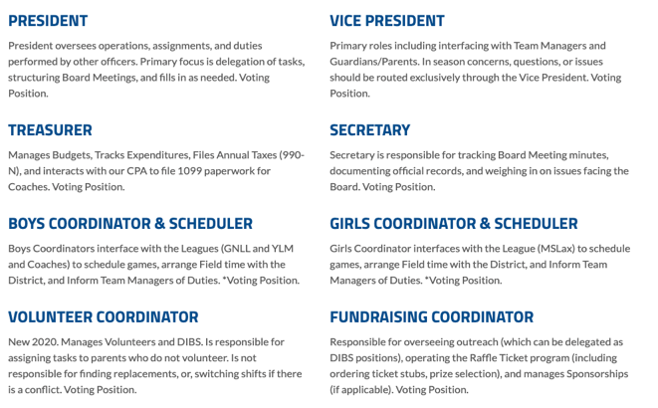

Registration:
Updates on numbers so far?
Promotional opportunities i.e.: Posting with area hockey associations, schools, community center, Newsleader??

I think this should keep us busy for a Tuesday! Lastly, I know that there is an away hockey game for the Bantams, I plan to skip the game and be in attendance. Can we get a quick response to this email as to who will or will not be attending??

Thank you,

Danielle Granroth
Interim VP
Sartell Sauk Rapids Lacrosse

