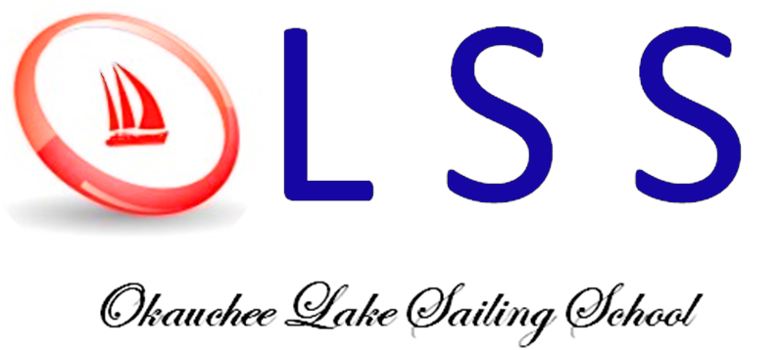
Post Office Box 152 Nashotah, WI 53058

www.okaucheesailing.org

Member US Sailing

January, 2023

Sailing Program
In 2023, there is a wide variety of options for all ages and skill levels. See okaucheesailing.org to get all the details. Coaches are US Sailing trained and interested in making sailing safe, fun; and a great overall experience.

For the Less experienced

KinderPram: These familiarization sessions are designed for young sailors aged 4 – 6. Young sailors get on the water with their adult companion in highly supervised non-threatening conditions. Classes are held Sunday evenings starting July 2nd . Its designed for fun.

Learn2Sail: Unsure where to start? Try Learn2Sail. This class is for new (or returning L2S graduates). The focus is on safety first, having fun with your classmates while learning new skills. US Sailing Certified instructors will introduce sailing fundamentals in a classroom setting before heading out to spend time on the water. While on the water, sailors will receive group and one-on-one coaching to gain confidence on the water. As the class learns together the instructors may introduce adventure sails. For June graduates, follow up classes are scheduled to allow those interested to continue learning by taking camps throughout the summer.

Youth Learn2Sail: For students aged 7 – 11, sign up for the “Learn2Sail” clinics June 12 – 16 (AM or PM), July 17 – 21 (AM or PM)

Teen Learn2Sail: For students aged 12 - 18, sign up for the “Learn2Sail” clinics June 12 – 16 (evenings).

Adult Lessons: Again this year, the OLSS will be offering hands on sessions for adults who wish to familiarize themselves with the sport. Initial sessions are evenings, June 28(classroom) and 29 (on water observation). Then follow-on sessions are scheduled which include sailing with experienced sailors

L2S graduates, and Some experience

Refresher Learn2Sail: Took L2S before? Take an advanced refresher course ! Sign up for the “Learn2Sail Refresher” on June 7 - 9. Classes will be held in X boats and OPTI depending upon age. Open to ages 7 – 18.

Reacher Camps: Reacher camps are for intermediate skill students wishing to improve sailing skills, but at present, not seeking to race. OLSS instructors will introduce new material in a classroom setting before heading out to spend the majority of the class on the water. Sailors will receive group and one-on-one coaching to improve skills and confidence on the water. As the class grows and learns together the instructors will introduce drills to hone skills. Swimming, sailing games, and other physical activities are interspersed throughout the day in order to make this a fun group experience for all!

Youth Reacher Camps: For students aged 7 – 11, sign up for the “Youth Reacher Camps June 19 – 28 and/or July 3 – 13 mornings.

Teen Reacher Camps. For students aged 12 – 18. Sign up for Teen Reacher camps June 26 – July 11. Evenings

Opti Learn2Race Camps: These camps are for intermediate skill students seeking to learn additional boat handling skills and eventually try racing. OLSS instructors will introduce new material in a classroom setting before heading out to spend the majority of the class on the water. Sailors will receive group and one-on-one coaching to improve skills and confidence on the water. As the class grows and learns together the instructors will introduce low key practice races to hone skills. Participating in evening races is optional. See “Opti Racing” below.

Opti Learn2Race Camps: For students aged 7 – 11, sign up for the “Learn2Race” Camps June 19 - 28 (afternoons), July 3 - 26 (afternoons)

More experienced Racing oriented

Opti Race Team: These sessions are for intermediate to advanced students who are interested in becoming competent skippers who participate in Okauchee races and potentially attend off lake competitions. Coaches will expand class curriculum to include tuning, sailing rules, and racing tactics. Attendees may attend any or all L2Race camps, participate in Okauchee races, and attend off lake events. See “Opti Racing” below.

Opti Racing: Students attending Opti L2Race camps or Race team and do not own their own Opti may use OLSS boats for evening races on Okauchee at no charge, or at off lake events by paying a charter fee. If there are more skippers than boats for any event, priority will be given based on a list of students placed in random order – all Opti Race Team skippers will be prioritized before L2Race skippers. When skippers race, their priority will be dropped to the bottom of their group. All 8 OLSS Optis are suitable for Okauchee races, but only 3 can be used off lake. Okauchee races will be mentored by coaches. Off lake events may have OLSS coaches in attendance to provide support, but typically during race mentoring is not allowed.

X Boat Classes: Lessons held for 8-16 year olds. Lessons run throughout the summer, beginning on June 12. Our sailors look forward to a larger fleet, great on lake competition and key regattas being run locally. The OLSS has competitive X boats available for interested sailors.

Adult Mentoring: In 2023, the OLSS will again leverage the skills of our top local competitors to assist local adult sailors wishing to enhance their competitive skills. The approach will be for more skilled sailors to engage in mentoring with their understudies. There are also numerous formal presentations usually held in conjunction with OLYC social events.

Open to All Children Regardless of Race, Color, National Origin, Religion or Sex

